#### 

Gustavo Francisco Neto Pereira

**A Influência do Design Generativo na Criação de Identidades Visuais Dinâmicas**

SÃO PAULO

2025

Gustavo Francisco Neto Pereira

**A Influência do Design Generativo na Criação de Identidades Visuais Dinâmicas**

Final Course Project submitted to the Institute of Technology and Leadership (INTELI), to obtain a bachelor's degree in Computer Engineering.

Advisor: Sergio José Venancio Júnior

SÃO PAULO

2025

Cataloging in Publication

Library and Documentation Service

Instituto de Tecnologia e Liderança (INTELI)

Data entered by the author.

(Cataloging record with international cataloging data, according to NBR 14724. The record will be completed later, after approval and before the final version is deposited. The completion of the cataloging record is the responsibility of the institution's library.)

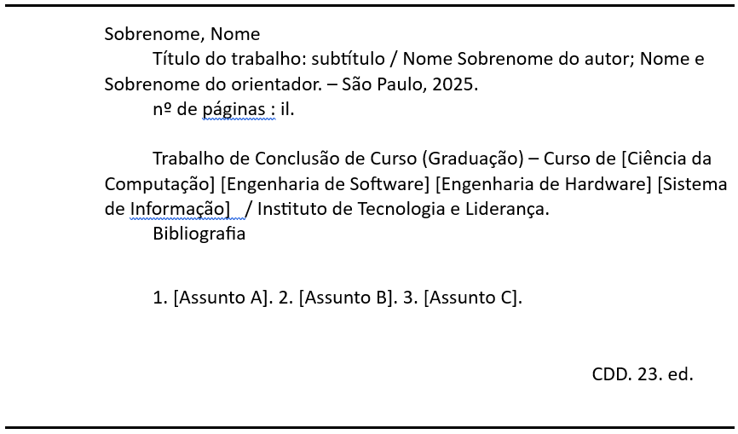

### Resumo

Pereira, Gustavo Francisco Neto. **A Influência do Design Generativo na Criação de Identidades Visuais Dinâmicas**. 2025. 54 folhas. TCC (Graduação) – Curso Engenharia de Computação, Instituto de Tecnologia e Liderança, São Paulo, 2025.

Esta pesquisa analisa a interseção do Design Generativo e do Branding, com foco na construção dinâmica de identidades visuais. Desafiando a percepção tradicional de uma identidade visual de marca como um símbolo estático, este estudo propõe que a expressão visual de uma marca pode evoluir ao longo do tempo através de sistemas algorítmicos. A pesquisa é fundamentada por referenciais teóricos extraídos do Branding, sistemas de Design e Computação Criativa. Uma revisão qualitativa da literatura embasa a conceituação, enquanto investigações empíricas, incluindo entrevistas semiestruturadas com profissionais de Design Generativo e experimentos práticos na geração de artefatos visuais (cobrindo tanto reinterpretações de identidades existentes quanto a criação de novos designs), aprofundam a discussão. Testes de percepção, conduzidos com revelação progressiva de contexto, são empregados para sustentar e refinar as proposições desta pesquisa. Esta abordagem busca não apenas ilustrar como as estratégias de Design Generativo fomentam a adaptabilidade e a inovação, mas também elucidar sua capacidade de reforçar ou desafiar a estética e a comunicação convencionais de uma marca.

**Palavras-Chave**: Design Generativo; Branding; Identidades Visuais Dinâmicas; Sistema de Identidade Visual; Computação Criativa.

### Abstract

Pereira, Gustavo Francisco Neto. **The Influence of Generative Design in the Creation of Dynamic Visual Identities**. 2025. 54 pages. Final course project (Bachelor) – Course Computer Engineering, Institute of Technology and Leadership, São Paulo, 2025.

This research examines the intersection of Generative Design and Branding, with a focus on the dynamic construction of visual identities. Challenging the traditional perception of a visual identity as a static symbol, this study posits that a brand’s visual expression can evolve over time through algorithm-driven systems. The research is underpinned by theoretical frameworks drawn from Branding, Design systems, and Creative Computing. A qualitative literature review anchors the conceptualization, while empirical investigations, including semi-structured interviews with Generative Design professionals and practical experiments in visual artifact generation (covering both reinterpretations of existing identities and the creation of novel designs), deepens the discussion. Perception tests, conducted with a method of progressive reveal of context, are employed to substantiate and refine the research propositions. This approach not only seeks to illustrate how Generative Design fosters adaptability and innovation, but also elucidates their capability to either reinforce or challenge conventional brand aesthetics and communication.

**Key words**: Generative Design; Branding; Dynamic Visual Identities; Visual Identity System; Creative Computing.

### Summary

1 Introduction 7

**2 Methodology 11**

3 Development 13

3.1 Literature Review 13

3.2 Industrial Landscape Analysis – Works Cataloging 23

3.3 Initial Experiments with Code 24

3.4 Interviews and Market Analysis 29

3.5 Final Experiment 31

4 Conclusion 40

References 41

Appendices 44

Attachments (optional item – NBR14724, item 4.2.3.4) 53

# Introduction

Without the help of a computer, it would not be possible to materialize so faithfully an image that previously existed only in the artist's mind. This may sound paradoxical, but the machine, often regarded as cold and inhuman, can help realize what is most subjective, unattainable, and profound in the human being. (Molnár, 1975 apud Bailey, 2018)

In an era where visual communication is increasingly mediated by technology, some brands are adopting Dynamic Visual Identity (DVI) systems, which require innovative approaches to building brand identities. This positions Generative Design as a tool with the potential to redefine creative processes and aesthetic outcomes (FEKETE, 2022). Despite its transformative capabilities, the adoption of this methodology within the context of Brazilian and global Graphic Design remains incipient, with gaps in understanding how its algorithmic techniques can challenge traditional paradigms, impacting visual perception and the audience's emotional connection with brands (VIEIRA; BRUSCATO, 2023). This study seeks to investigate the influence of Generative Design on Branding processes and the creation of visual identities, focusing on aesthetic innovation and the enhancement of creative processes, exploring everything from its theoretical foundations to practical applications in the industry.

The conceptual foundations of this study stem from the essential distinction between Brand and Branding. While the brand is understood as a conceptual entity anchored in a name, logo, or visual identifier capable of activating cognitive, emotional, and symbolic associations (AVIS; HENDERSON, 2021), Branding corresponds to the strategic process of shaping, managing, and evolving brands and these associations in alignment with organizational goals, cultural contexts, and public perceptions (SCHROEDER, 2005; SCHROEDER, 2017). From this perspective, brands operate as sociocultural artifacts that articulate meanings, narratives, and values, functioning simultaneously as economic assets and semiotic systems. A Visual Identity, composed of elements such as a logo, typography, color palette, and communicative style, materializes these abstractions and guides the construction of consistency, recognition, and cultural relevance. Thus, Branding constitutes a continuous practice of sense-making, in which visual elements play a central role by structuring experiences, guiding decisions, and consolidating emotional bonds. This provides a starting point for investigations into the application of generative systems in brand identities.

Visual Identity constitutes the tangible manifestation of the brand, articulating recognition, emotion, and narrative within a coherent system of signification. More than an aesthetic resource, it operates as a semiotic structure capable of communicating values, positioning, and differentiation in a competitive context, in addition to sustaining affective bonds and cultural memories (LY DANG, 2018). By integrating consistency and adaptability, visual identity becomes a strategic mechanism that guides perceptions, reinforces symbolic continuity, and ensures relevance in increasingly dynamic communication ecosystems. In this sense, understanding a visual identity means understanding how a brand builds meaning through visual experiences. In this project, Visual Identity is an object of study for establishing dynamic visual identity systems that utilize Generative Design.

Generative Design, in turn, is a creative practice that employs analog or digital systems as central tools, characterized by the intentional introduction of stochastic (random) elements and the generation of variants within the creative process. This allows for the production of unpredictable and diverse results, yet contained within a set of rules defined by the author (GALANTER, 2003). Artists and designers thus act as system architects, defining parameters, limits, and degrees of randomness, while the systems take over the operational execution, varying parameters and producing results automatically (BAILEY, 2018). It is common in computational generative practice to incorporate interactivity, allowing the viewer to manipulate system parameters and generate variants according to their choices. Furthermore, it is fundamental to note that the essence of this creative practice lies in the structured process of rule creation and the degree of autonomy granted to the system performing those rules, and not necessarily in the resulting aesthetics or the computational technology used. The figures below demonstrate works whose complexities evidence structures of repetition and variation, typical of a generative process that uses computers as rule executors.

Figure 1: Vera Molnár, (Dés)Ordres, 1974. Various concentric quadrilaterals that vary the positioning of their vertices, generating graphic variations of different densities.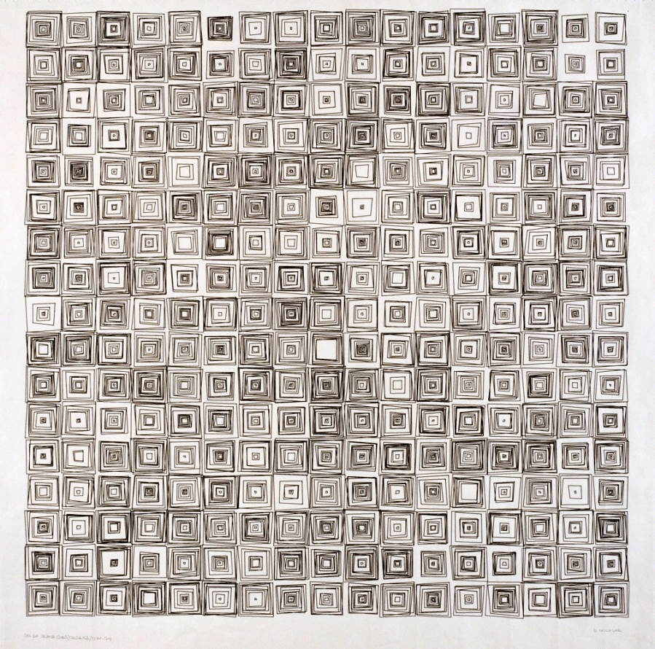

Source: DIGITAL ART MUSEUM, [s.d.]

Figure 2: John Maeda. Florada, 2003. Various semi-transparent flower graphics, varying petal shapes, positions, and colors.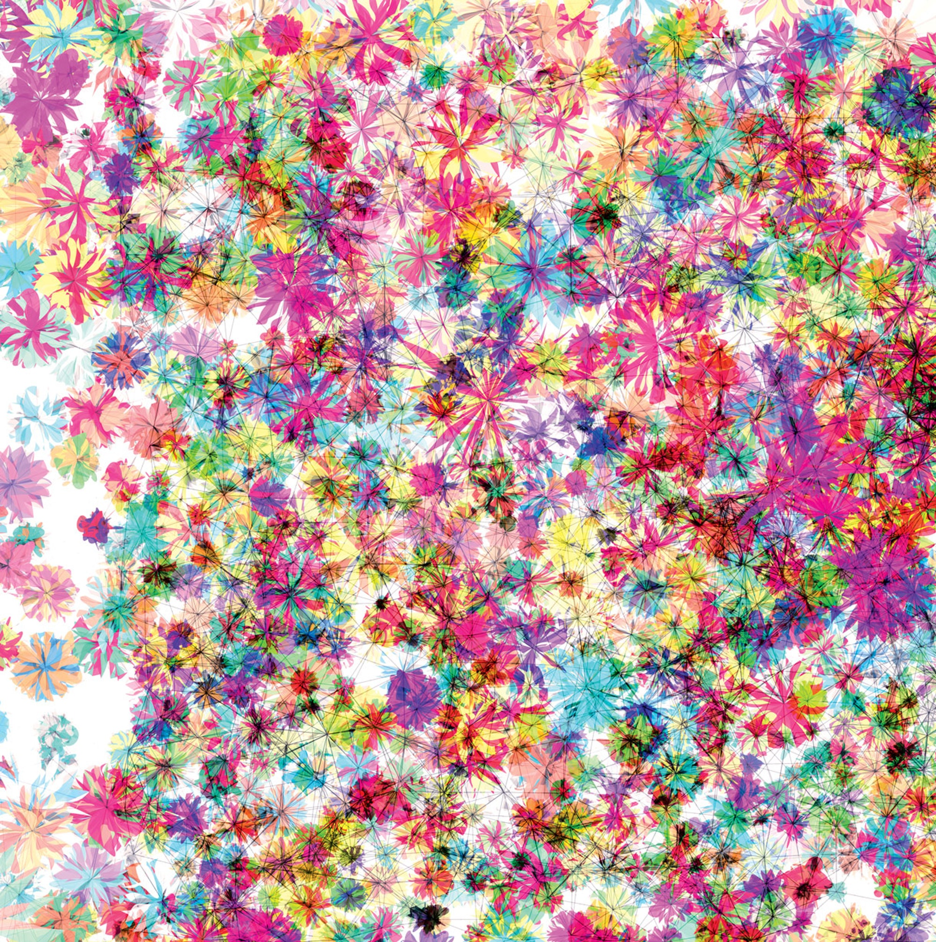

Source: MAEDA, 2004.

Figure 3: Patrik Hübner. *Schwanensee*. 2018. A 3D model of a dancer performing is printed several times on the same screen over time, while the camera positioning also varies.

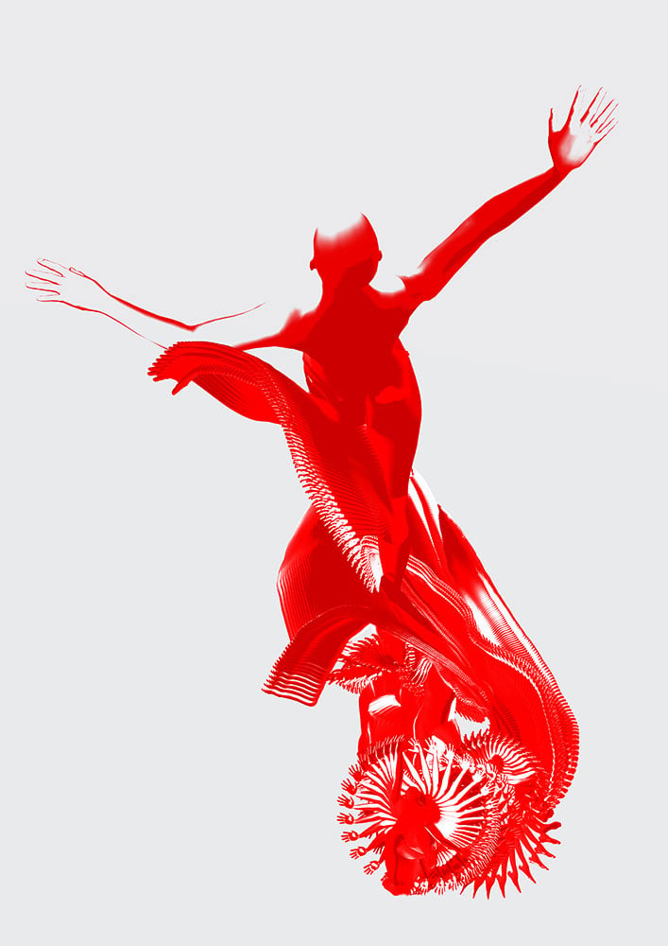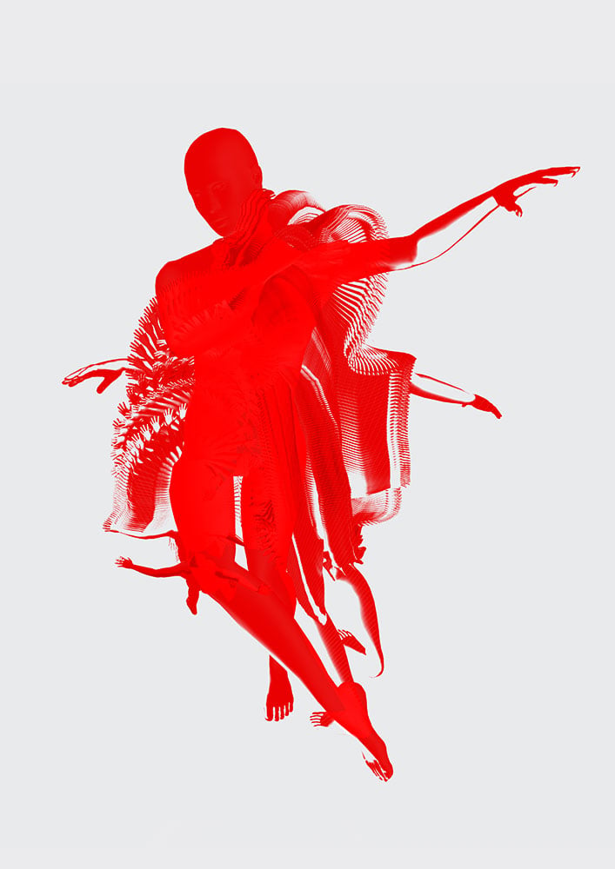

Source: HÜBNER, 2018

The general objective of this research is to investigate how Generative Design influences the processes of creating Visual Identities, analyzing its potential to promote aesthetic innovation, diversify aesthetic experiences, and redefine traditional Branding paradigms. The research seeks to understand how generative systems applied to brands can transform Design practice, both conceptually and operationally, articulating theoretical foundations, practical experimentation, and public perception to evaluate the impact of these approaches in the field of Dynamic Visual Identities.

The specific objectives include:

* Mapping the conceptual and historical foundations of generative design and its relationship with dynamic visual identities;
* Analyzing the industrial landscape to identify challenges, opportunities, and trends in the use of generative systems by companies and design studios;
* Investigating how professionals in the field perceive the role and limits of generative design in contemporary branding;
* Developing practical experiments in generating graphic artifacts, reinterpreting existing visual identity elements or creating new ones;
* Applying perceptive tests to evaluate the emotional, imagistic, and narrative impact of the generated solutions.

The integration of Generative Design with the areas of Visual Identity and Branding reveals itself as a significant strategic challenge due to the profound transformations this paradigm imposes on communication processes, brand management, and Design practice. As Fekete (2022) points out, the transition from static identities to dynamic systems (Dynamic Visual Identity)—based on algorithms, data, and interactivity—requires a structural reconfiguration of traditional practices, shifting the role of the designer, redistributing control between brand and audience, and introducing unprecedented levels of systemic autonomy. This complexity is intensified by the need to reconcile variability with identity coherence, as well as to integrate technology, consumer behavior, and market strategies in rapidly changing environments. Furthermore, the author relates conceptual confusion, difficulties in aesthetic evaluation, training gaps in programming, and the lack of consensus on quality criteria or appropriate nomenclature, which compromises the broad adoption of these systems and reinforces the urgency of studies that clarify their theoretical, technical, and communicative implications. In this context, this investigation into Dynamic Visual Identities using generative systems is justified. It seeks to contribute to a deeper understanding of how brands can operate with generative systems, balancing flexibility, participation, and symbolic consistency in communication ecosystems that are increasingly dynamic and shaped by rapid technological advancement.

# Methodology

The present research, exploratory and qualitative in nature, employs a methodology divided into five axes, related to the specific objectives of the study. First, to map the conceptual and historical foundations of generative design and its relationship with dynamic visual identities, a narrative literature review was conducted. This stage involved the selection and critical reading of academic articles, books, and case studies dealing with the evolution of generative practices in Design, as well as core authors in the fields of Branding and Visual Identity. The review allowed for the construction of the theoretical framework that guided subsequent analyses.

Next, to analyze the industrial landscape, a systematic cataloging of generative art and design works related to brand visual identities was conducted. The survey gathered data regarding the names of the works, authors, year of publication, techniques employed, and related keywords (tags). The pieces were organized into a comparative table containing complete references and curatorial notes. This process made it possible to identify emerging trends, technical challenges, and overlaps between generative design practices and solutions applied to visual identities.

The third methodological axis consisted of investigating the perception of professionals in the field regarding the role and limits of Generative Design in contemporary Branding. To this end, semi-structured interviews were conducted with designer-programmers who work with dynamic identities. An interview script was constructed based on the research objectives and grounded in open-ended questions that encouraged reflection on the practice, context, and future of the field. The interviews were analyzed using the Content Analysis technique (Bardin, 2011). The procedure followed three stages: in the pre-analysis, interview transcriptions were defined as the *corpus*, followed by a familiarization reading guided by the study objectives and script questions. In the second stage, the *corpus* was subjected to coding and categorization, using the "theme" as the unit of recording. The identified codes were grouped into thematic categories aligned with the original structure of the script. In the final stage, the categorized set was interpreted to produce inferences and syntheses articulating the interviewees' discourses, highlighting convergences, divergences, and particularities between contexts.

The fourth axis involved the development of practical experiments in Generative Design. Initially, exploratory exercises were proposed using the Processing and P5.js tools, in which shape, color, and other visual identity elements were manipulated through simple algorithms to test visual behaviors. In a later stage, a final experiment was conducted that reinterpreted the identity of an established brand, exploring dynamic variations based on generative rules. This practical stage allowed for the observation of how different algorithmic structures impacted the coherence, expressiveness, and legibility of a brand.

Finally, to evaluate the emotional, imagistic, and narrative impact of the generated solutions, perceptive tests based on progressive context revelation were applied. This procedure was structured based on general qualitative methodologies applied in Marketing (MALHOTRA, 2018) and is based on more specific methods such as projective techniques (DONOGHUE, 2000) and perceptual elicitation (DZYABURA; PERES, 2020). Broadly speaking, participants observed different graphic variations produced by the final experiment without prior information about the brand. Subsequently, they were gradually exposed to additional layers of context. Their responses were recorded and analyzed with a focus on aesthetic perception, symbolic interpretation, and perceived identity coherence. This procedure allowed for an evaluation of how generative variations influenced public interpretation and which elements contributed to reinforcing or weakening the brand experience.

This integrated methodology allowed for the combination of theory, practice, expert perception, and public reception, establishing a foundation for understanding the potentials and challenges of Generative Design applied to Branding and Visual Identities.

# Development

This section details the methodological path and the partial results of the research, which unfolds into five central stages: theoretical foundation, market landscape investigation, interviews with specialists, initial and final technical experimentation, and the structuring of perception tests.

## Literature Review

The research began with a narrative literature review to establish a conceptual foundation, already partially explored in the introductory section of this article. This stage investigated three pillars: Branding, Visual Identity, and Generative Design.

In academic discourse, precise conceptual distinctions are fundamental. Central to this study is the differentiation between brand and branding. Adopting the Label and Associations Model (LAM), a brand is defined as a conceptual entity anchored in a name, logo, or visual identifier that indicates the product's origin and stimulates cognitive, emotional, or symbolic associations. These associations, although diverse, remain linked to the brand's central identifier (AVIS; HENDERSON, 2021). Branding, in contrast, constitutes the strategic process of intentionally shaping, managing, and evolving these associations to align them with organizational goals, cultural contexts, and consumer perceptions (SCHROEDER, 2005; SCHROEDER, 2017).

Beyond their corporate utility, brands and Branding practices function as ideological constructs operating at the intersection of commerce, culture, and academia. Schroeder (2017) characterizes brands as sociocultural artifacts that act simultaneously as economic assets and semiotic systems, shaping consumer identities, corporate narratives, and even social values. This duality positions Branding as a sense-making practice, in which visual, linguistic, and symbolic elements articulate to build brand narratives (SCHROEDER, 2005).

From the consumer's perspective, brands transcend merely transactional functions, evolving into relational personas capable of generating trust, exclusivity, and a sense of community (WHEELER, 2017). For organizations, they represent strategic assets essential for differentiation and sustained market relevance.

Figure 4: Brand touchpoints, highlighting how each interaction represents an opportunity to increase awareness and customer loyalty.

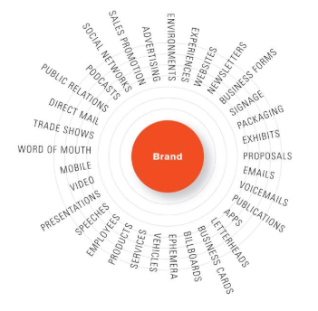

Source: WHEELER, 2017, p. 3.

As illustrated in Figure 4, brand touchpoints constitute critical moments of perception formation. These encounters collectively define the brand image, encompassing reputation, values, and cultural relevance. Distinctly, Visual Identity refers to the deliberate materialization of these abstractions through visual and sensory elements such as logos, typography, color systems, and tonal voice (WHEELER, 2017).

Branding is not a static endeavor but a continuous and iterative process of adaptation, requiring constant updates in the face of cultural shifts, market dynamics, and consumer expectations. Avis and Henderson (2021) emphasize that effective Branding demands organizational alignment from executive strategy to employee conduct, ensuring cohesive communication and consistent experiences.

Visual elements are central to Branding, functioning as both identifiers and cultural signs. Schroeder (2005) argues that brands are inherently visual; logos, packaging, and advertisements rely on Design to encode meanings. The example of Andy Warhol’s *Campbell’s Soup* series in Figure 5 demonstrates how a brand's visual identity can become a cultural icon, revealing that Design surpasses aesthetics to consolidate itself as a historical artifact.

Figure 5: Andy Warhol. Campbell's Soup Cans. 1962.

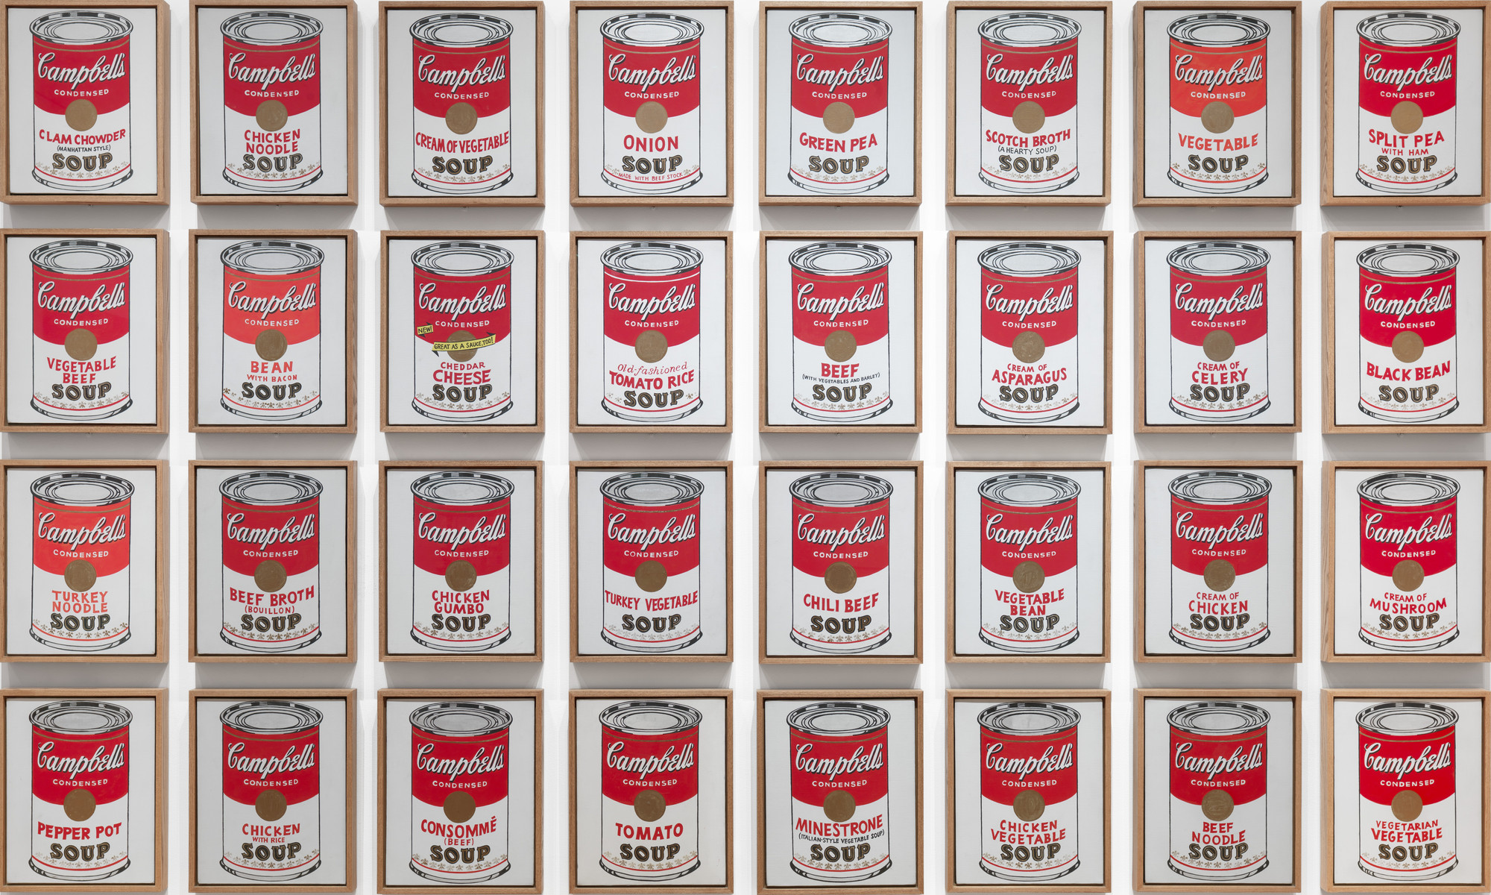

Source: THE MUSEUM OF MODERN ART, [s.d.]

Visual Identity constitutes the tangible manifestation of a brand, synthesizing recognition, emotion, and narrative into a cohesive system. It transcends the aesthetic dimension, acting as a semiotic structure capable of communicating brand values, differentiating competitors, and fostering consumer loyalty (LY DANG, 2018). A robust Visual Identity System (VIS) integrates typography, color, language, and logo into a unified strategy, balancing consistency and adaptability to meet hyper-modern demands (LELIS et al., 2020; VAN NES, 2012).

The logo functions as the centerpiece of the VIS, condensing the brand's essence into a singular graphic form that synthesizes identity, values, and market positioning. Beyond a simple visual abbreviation, it operates as a semiotic anchor, encoding complex narratives into structural elements such as shapes, symbols, and typographies that resonate across different cultural and linguistic contexts (LY DANG, 2018).

An elucidative example is *American Alphabet* by Heidi Cody (WHEELER, 2017), which decomposes iconic logos into typographic fragments, shown in Figure 6. Even with partial occlusions, observers instantly recognize brands like Disney or Ray-Ban, demonstrating how deeply visual identities become rooted through typographic and chromatic repetition. This phenomenon aligns with the findings of Lelis (et al., 2020), according to which even dynamic logos preserve structural axes to ensure recognition amidst variation.

Figure 6: Heidi Cody. Modern American Alphabet. 2000.

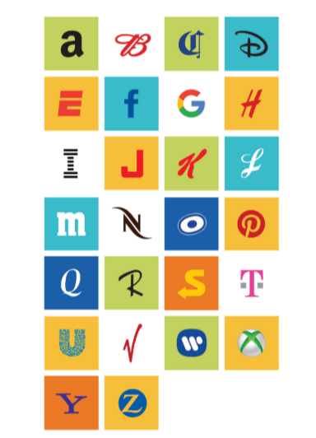

Source: WHEELER, 2017

Brands like Nike and Apple exemplify symbolic minimalism. By reducing their logos to abstract shapes (the swoosh, the apple silhouette), they achieve cross-cultural immediacy. Nike's evolution from a wordmark to a standalone symbol reflects a strategic process of simplification that ensures scalability across digital and physical media (WHEELER, 2017). This minimalism, however, relies on decades of chromatic consistency, such as Nike's black-and-white palette (Figure 7) and Apple’s monochromatic apple (Figure 8), elements that sustain recognition (LELIS, 2019).

Figure 7: Evolution of the Nike logo over the years. Source: MCEVOY, 2024.

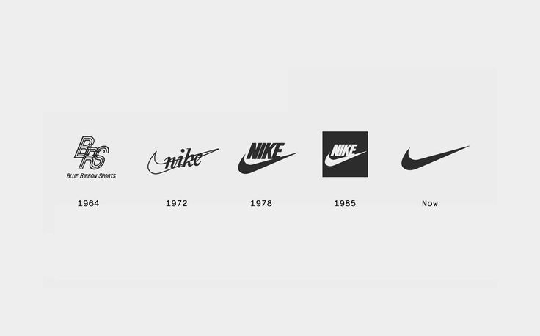

Source: MCEVOY, 2024.

Figure 8:Evolution of Apple’s logo throughout the years.

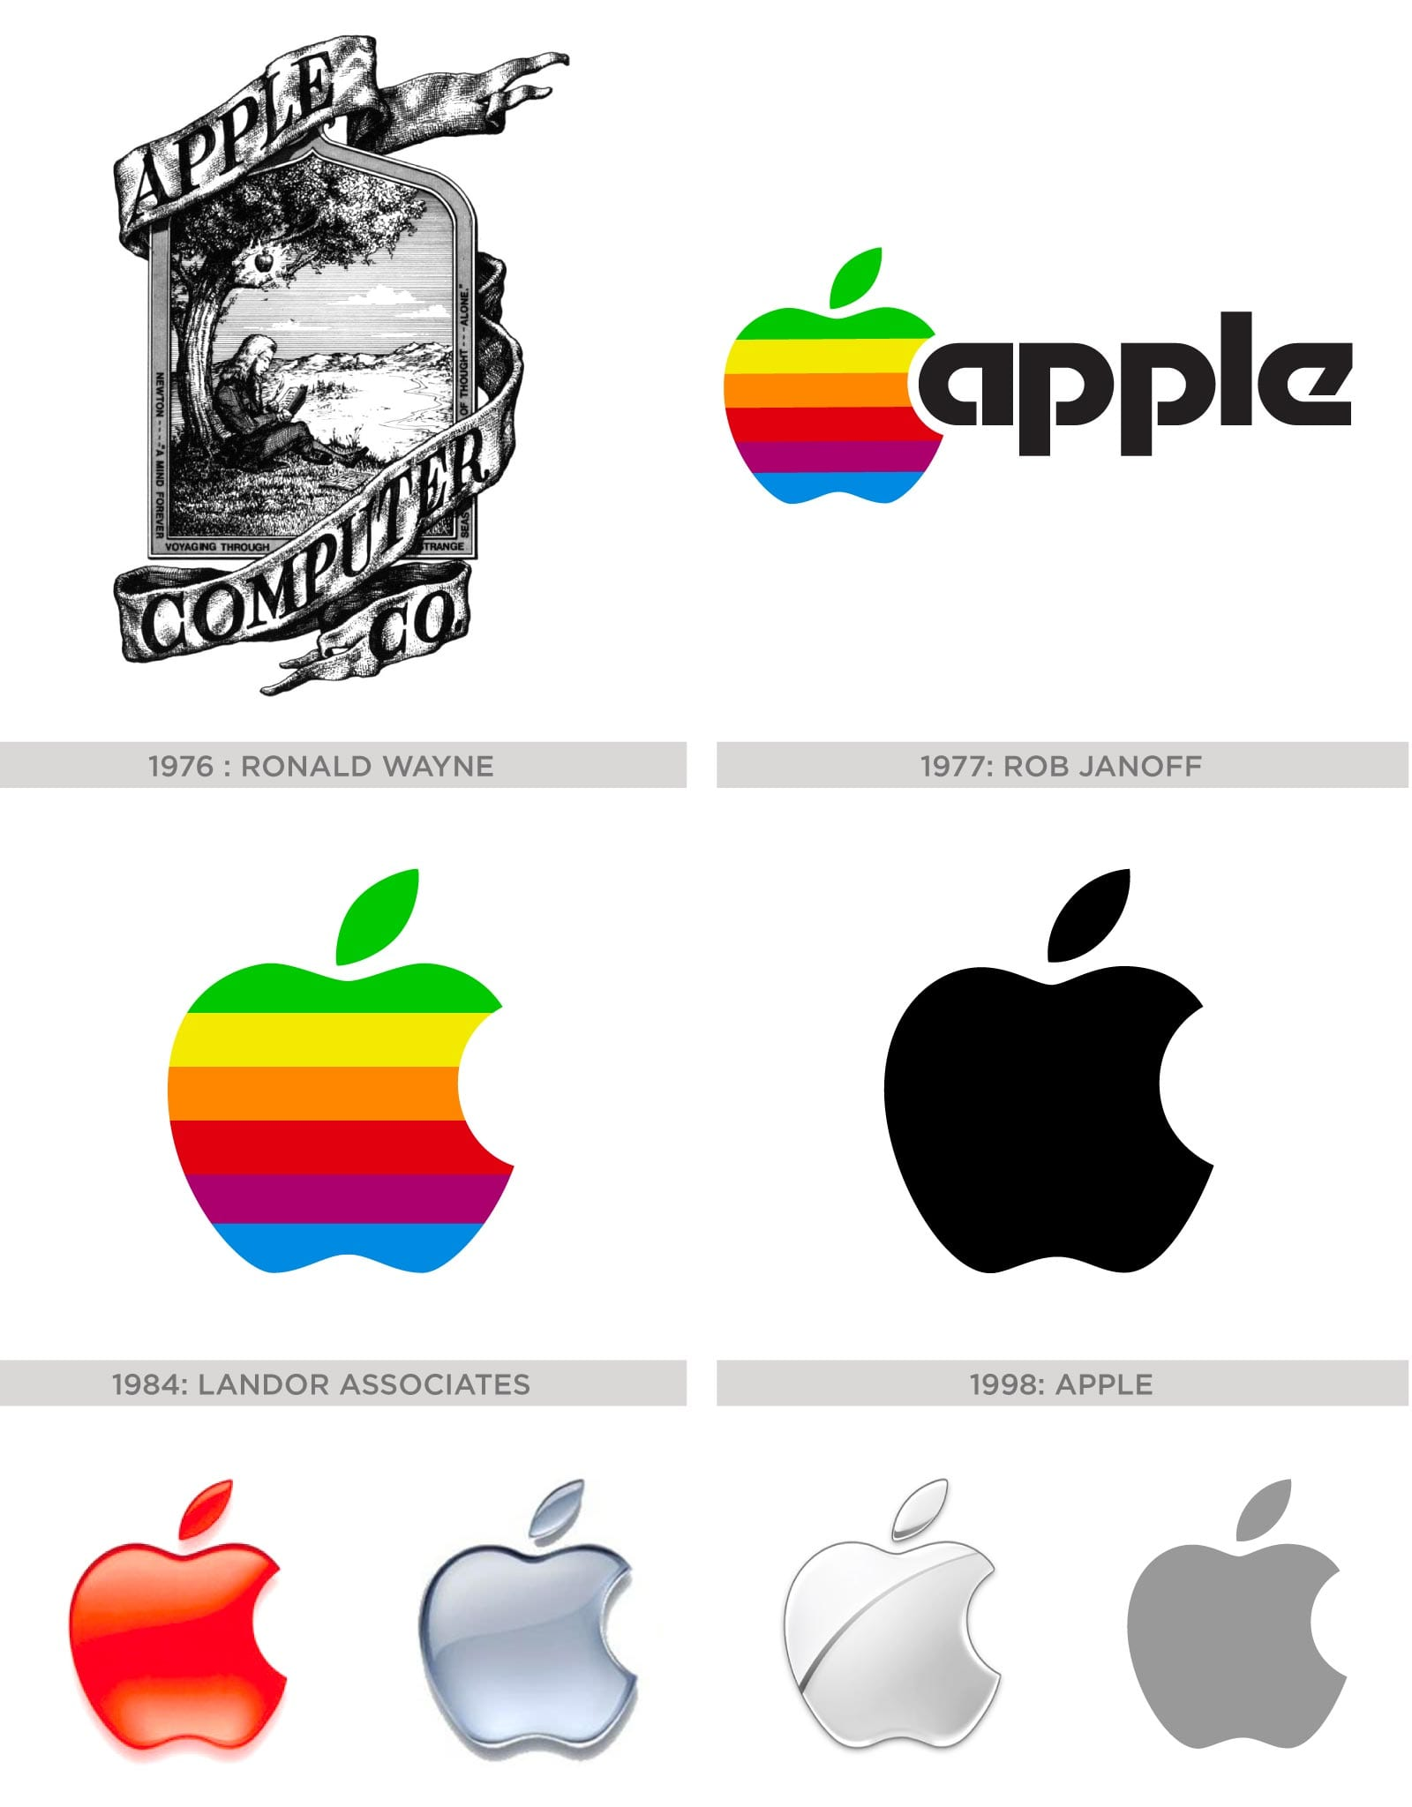

Source: MSN, 2025.

Typography transcends textual representation and embodies the brand's voice. Serif fonts like Times New Roman can evoke tradition and authority, while sans-serif fonts like Verdana suggest modernity and accessibility (LELIS et al., 2020), as demonstrated in some applications in Figure 9. Essentially, legibility (the clarity of individual characters) and readability (the understanding of text as a block) must coexist (LELIS et al., 2020).

Figure 9: Examples of serif and sans-serif font applications.

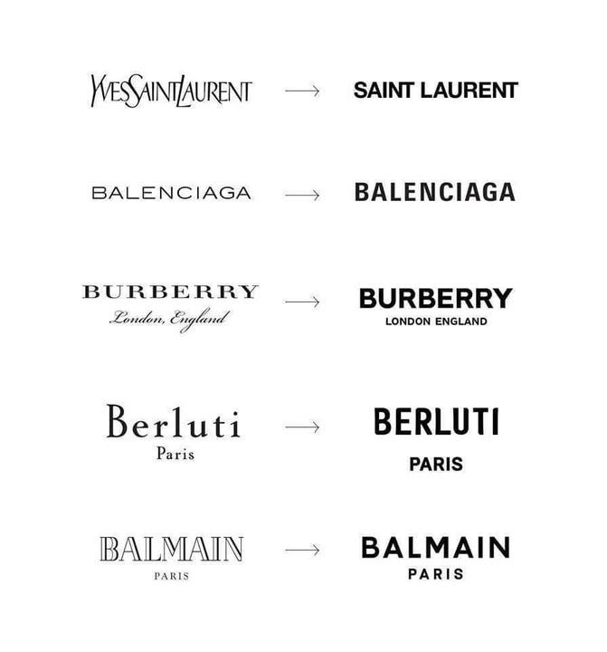

Source: NOCLIMA, 2024.

The role of color in Visual Identity also goes beyond the aesthetic sphere; it encodes meanings and influences behaviors. Its definition involves three perceptual attributes: hue (spectral position), value or luminosity (lightness or darkness), and saturation **or** chroma (intensity) (LELIS, 2019). It is possible to organize chromatic harmonies into categories such as monochromatic, analogous, complementary, triadic, and tetradic, as shown in Figure 10, offering systematic models of composition.

Figure 10: Categorization of chromatic harmonies.

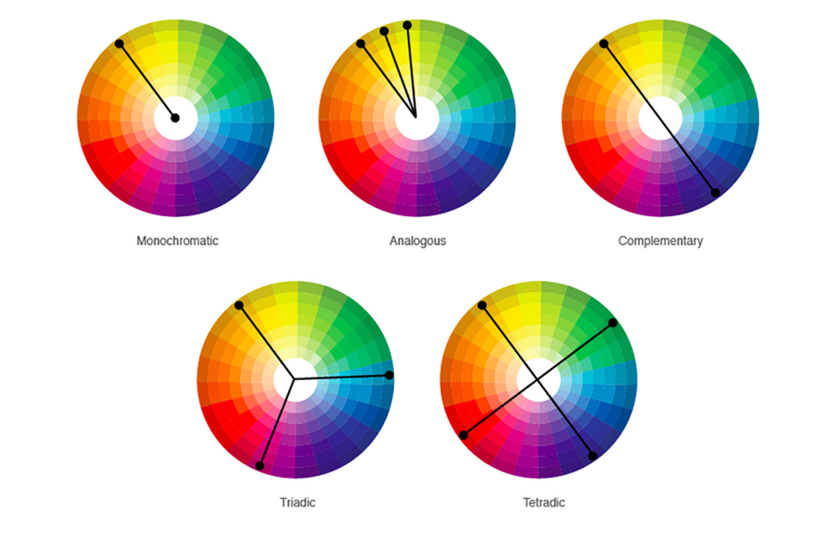

Source: LELIS, 2019.

The effectiveness of a visual identity results from the interaction between logo, typography, and color. Dynamic brands like MTV illustrate this integration: their logos change in texture and color but preserve typographic boundaries to maintain recognition (LELIS et al., 2020), as shown in Figure 11.

Figure 11: Variations of the MTV logo.

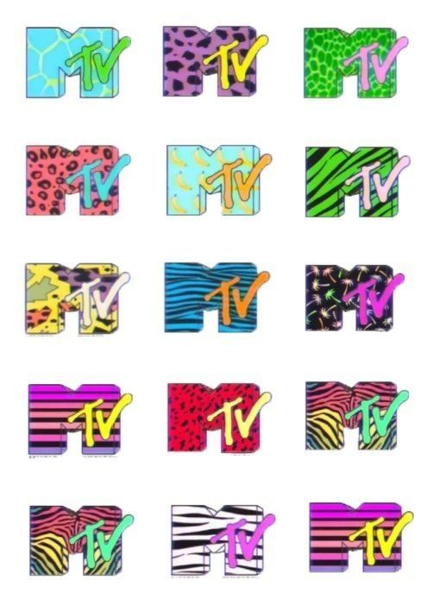

Source: PINTEREST, [s.d.].

Regarding Generative Design, Philip Galanter states that:

[It] refers to any [design] practice where the [designer] uses a system, such as a set of natural language rules, a computer program, a machine, or other procedural invention, which is set into motion with some degree of autonomy, contributing to or resulting in a completed work of [design]. (GALANTER, 2003)

Generative Design consists of a creative practice that employs systems "with some degree of autonomy" as essential creation tools. Its central distinction lies in the intentional introduction of stochastic elements into the creative process, generating unpredictable and diverse results within a set of rules provided by the author. According to Galanter, generative systems operate in the zone of effective complexity, in which order and disorder coexist to produce patterns that are both structured and unpredictable (GALANTER, 2003). Figure 12 represents these relationships.

Figure 12: Relationships between order, disorder, and effective complexity in generative systems.

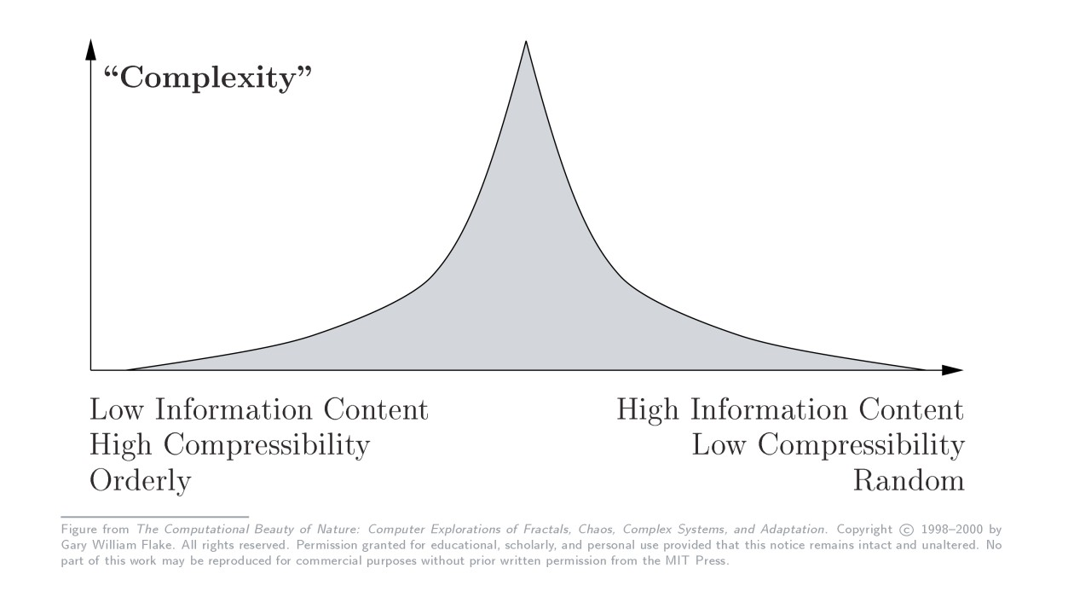

Source: FLAKE apud GALANTER, 2003

These stochastic elements not only expand the formal repertoire of the work but also reconfigure the dynamics of creation, allowing the artist to act as a system architect—defining parameters, limits, and degrees of randomness—while the system takes over operational execution (BAILEY, 2018).

When designers use computational systems for generative creation, scalability becomes one of the method's most notable features. By delegating repetitive and processing-intensive tasks to algorithms, generative design optimizes processes that would be unfeasible manually, such as the exhaustive exploration of variations or the simulation of emergent behaviors (BAILEY, 2018). However, it is essential to emphasize that technology does not define the essence of generative art; what characterizes it is the adoption of systems with some degree of autonomy, whether analog (such as mathematical rules or physical processes) or digital (such as programs and algorithms).

The distinction between what is or is not generative design stems primarily from the creative process and, at times, the resulting aesthetics. Although generative works often exhibit complex patterns, modular repetitions, or systematic variations, these visual characteristics are not sufficient on their own to classify them. In art history, for example, Jackson Pollock's gesture paintings, despite their seemingly chaotic patterns, are not generative, as they depend on the artist's continuous decisions. In contrast, Sol LeWitt’s *Wall Drawings* are based on predefined instructions and can align with the concept of generative art, even when executed manually (GALANTER, 2003).

In summary, generative art and design are defined by the dialectical relationship between the artist and systems endowed with a certain degree of autonomy, in which creative control is constantly negotiated. The artist establishes rules, limits, and aesthetic guidelines, while the system interprets and transforms them, generating results that can challenge, complement, or expand the initial intention. This interaction—sometimes collaborative, sometimes tense—transcends mere technical application, converting the creative process into an investigation of the boundaries between predictability and emergence (GALANTER, 2003; BAILEY, 2018).

Generative design transforms visual identities by replacing static logos with dynamic, context-responsive systems. An emblematic example is that of Casa da Música, whose identity adapts to real-time inputs: the logo transforms based on architectural perspectives and color palettes extracted from event images, ensuring that each application reflects the diversity of the venue's cultural programming, as shown in Figure 13.

Figure 13: Variations of the Casa da Música visual signature.

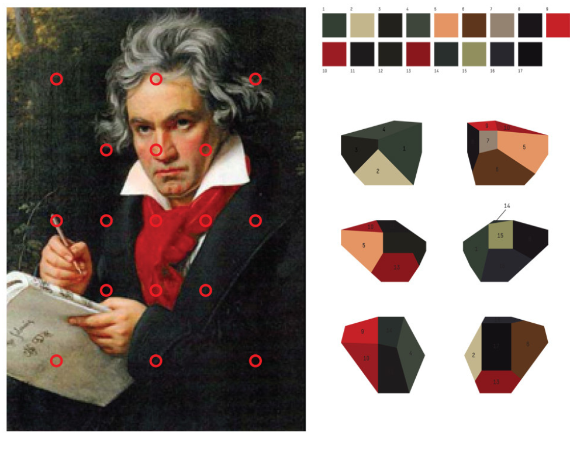

Source: SAGMEISTER, 2007.

Similarly, the branding for the Nordkyn organization, as shown in Figure 14, integrates weather data such as wind direction and temperature to generate logos that update every five minutes, incorporating the regional slogan “Where nature rules.” These cases demonstrate how generative design transcends aesthetic novelty by incorporating variability and environmental responsiveness into the brand's DNA. By prioritizing algorithmic structures over fixed forms, such systems respond to the need for identities capable of evolving according to contextual, cultural, or climatic changes—challenges that static identities, by nature, cannot resolve (GUIDA, 2014).

Figure 14: Variations of the Nordkyn logo.

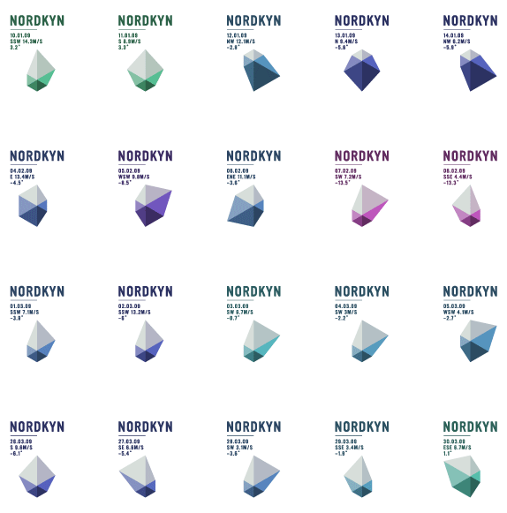

Source: NEUE DESIGN STUDIO, 2012.

## Industrial Landscape Analysis – Works Cataloging

To gain an initial understanding of the industrial landscape regarding the application of Generative Design in Branding and Visual Identities, a catalog of works was compiled to map existing authors and techniques. The catalog gathers data on the names of the works, authors, year of publication, techniques employed, and related keywords (tags). It features works by figures such as Patrik Hübner and André Burnier, among others, referencing both national and international productions on applied Generative Design. This catalog served as a reference for the subsequent practical experiments and can be found at the end of this article in the Appendices section. This survey does not claim to be exhaustive or to cover the entirety of global production in the sector.

## Initial Experiments with Code

The initial experiments aimed to explore, in a controlled manner, fundamental aspects of Generative Design applied to the construction of dynamic visual identities. Before conducting the final experiment with the PIET brand, practical studies were carried out to separately investigate two recurring structural axes in generative systems: chromatics (color) and morphology (form). These exercises functioned as conceptual prototypes designed to understand how simple algorithmic rules can produce coherent and aesthetically consistent variability, establishing parameters for the subsequent phase of the research.

### Experiment 1 – Chromatics (“Bloom”)

The first experiment focused on the manipulation of chromatic palettes within a generative environment. Developed in Processing, the system produced floral compositions that emerged with each user interaction. Each visual element—petals, shapes, and transparencies—was generated through controlled randomization, receiving a color selected randomly from a predefined palette.

The exploration demonstrated how a restricted set of colors can generate significant visual diversity when combined with rules of overlapping, opacity, and formal variation. The use of transparencies revealed new emerging harmonies resulting from the intersection of forms and colors, expanding the composition's expressive repertoire without compromising coherence. The “Bloom” experiment thus functioned as a proof of concept for the idea that brand chromatic systems can operate as dynamic entities rather than fixed guidelines.

Figure 15: Bloom. Organic and semi-transparent shapes emerge from controlled randomization, varying colors, sizes, transparency, and directions with each interaction.

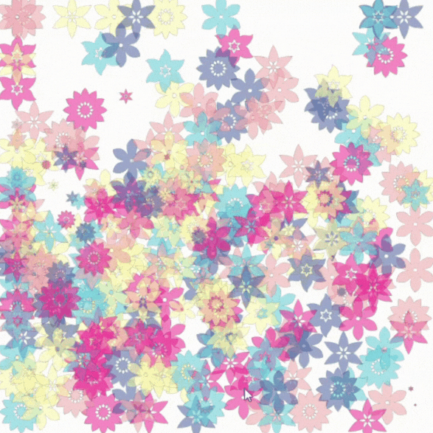

Source: By the author, 2025.

### Experiment 2 – Morphology (“twenty one bars”)

The second study shifted focus to the morphological dimension, investigating the generation of form based on data reading. Inspired by Patrik Hübner’s “Philharmonie Luxembourg” project, the system was also developed in Processing and produced audio-reactive visualizations. To achieve this, graphic compositions were modulated by parameters derived from the waveform and the sound spectrum. With each segment of the music, bars were deformed, expanded, or contracted in response to the sonic stimulus.

To integrate the findings from the chromatic study, each song used in the test was associated with a color palette extracted from the visual identity of the respective Twenty One Pilots albums. This strategy allowed for the observation of how the combination of dynamic morphology (data-driven) and stable chromatics (brand-driven) can produce compositions that are simultaneously expressive and recognizable. The study highlighted the potential of data-based morphological systems as a viable alternative for visual identities seeking responsiveness and contextuality.

Figure 16: twenty one bars: Clancy. Generative audio-reactive visualization. The bars' morphology is modulated by sound dynamics. The chromatic palette was extracted from the visual identity of the album Clancy (2024).

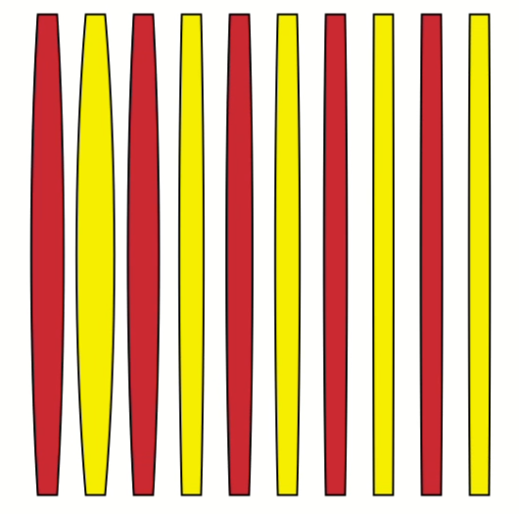

Source: By the author, 2025.

Figure 17: twenty one bars: Scaled and Icy. Generative audio-reactive visualization. The bars' morphology is modulated by sound dynamics. The chromatic palette was extracted from the visual identity of the album *Scaled and Icy* (2021).

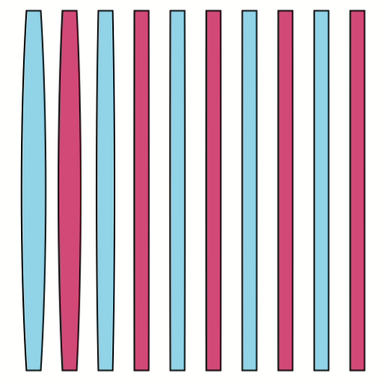

Source: By the author, 2025.

Figure 18: twenty one bars: Trench. Generative audio-reactive visualization. The bars' morphology is modulated by sound dynamics. The chromatic palette was extracted from the visual identity of the album *Trench* (2018).

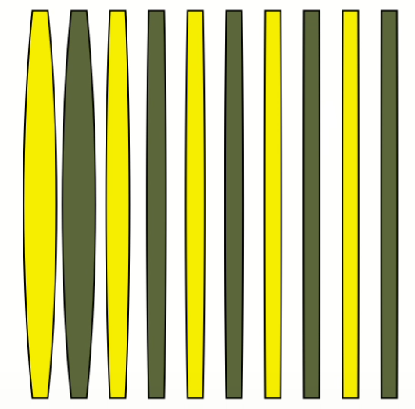

Source: By the author, 2025.

Figure 19: twenty one bars: Blurryface. Generative audio-reactive visualization. The bars' morphology is modulated by sound dynamics. The chromatic palette was extracted from the visual identity of the album *Blurryface* (2015).

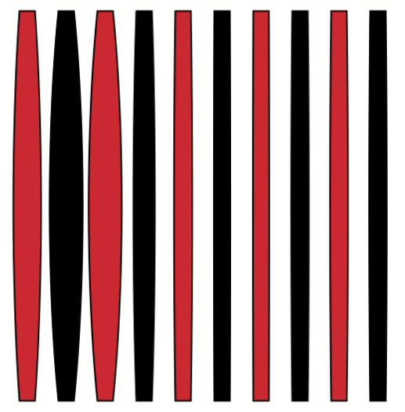

Source: By the author, 2025.

Figure 20: twenty one bars: Vessel. Generative audio-reactive visualization. The bars' morphology is modulated by sound dynamics. The chromatic palette was extracted from the visual identity of the album *Vessel* (2013).

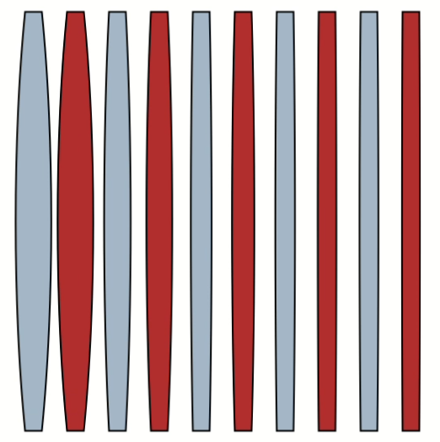

Source: By the author, 2025.

### Synthesis of Initial Experiments

These initial experiments fulfilled the role of establishing the formal and methodological foundations for the development of the final experiment. The study of chromatics revealed the importance of controlled variability and visual emergence as a way to generate aesthetic richness without identity rupture. The study of morphology demonstrated how reactive systems can reinforce sensory narratives and brand behaviors.

By integrating color and form through simple computational rules, these prototypes provided fundamental insights into the limits, potential, and mechanisms necessary for constructing an applied generative visual identity, which would later be deepened in the case of PIET.

## Interviews and Market Analysis

To investigate the professional landscape and the practical challenges of applying Generative Design to visual identities, semi-structured interviews were conducted with two specialists with complementary profiles: Patrik Hübner, operating within an international context, and André Burnier, focused on the Brazilian national market. Both professionals consented to the publication of their names and contributions to this research.

Patrik Hübner is a designer who, despite having a background in communication design and branding, has been programming since his teenage years. Today, he works as a generative branding specialist, merging his skills in programming and brand strategy. André Burnier, on the other hand, defines himself as a "designer who learned to program." With a background in traditional graphic design (publishing, packaging), he transitioned to generative design as a self-taught practitioner and now frequently serves as a specialist for design agencies that lack this internal competency.

### 

### Data Collection and Analysis Methodology

The interviews followed a semi-structured script (available in Appendix II of this work), focusing on three thematic blocks:

1. Creative Process, Tools, and Workflow;
2. Relationship with the Market and Clients;
3. Aesthetics, Innovation, and Brand Perception.

The interview transcriptions (the research *corpus*) were subjected to Content Analysis following the methodology of Laurence Bardin (2011). The process followed three chronological stages:

* Pre-analysis: A "floating reading" of the *corpus* for familiarization and initial systematization of the material.
* Material Analysis: Coding and categorization of the *corpus*. The chosen unit of recording was the "theme," identifying core meanings aligned with the research objectives.
* Treatment of Results and Interpretation: The categorized data were interpreted to build inferences and a synthesis articulating the discourses, focusing on convergences and divergences between the national and international contexts.

The analysis revealed clear patterns in three main areas:

1.Creative Process, Tools, and Workflow: There was a convergence in viewing code as a tool rather than an end. However, the timing of its application differs.

* Patrik Hübner describes his process as a fundamental shift: instead of "superimposing" a brand identity through Generative Design, he seeks to understand the brand's "phenomenon" so that it "projects itself" from data. His workflow is based on web technologies (such as WebGL and Vue.js) to ensure interactivity and reach.
* André Burnier positions programming as a later stage. The process begins on paper to obtain a "minimal graphic direction." Often, his work consists of "translating" or "reproducing something that was done without programming," acting as the technical specialist who enables the agency's creative idea.

2.Relationship with the Market and Clients: This category revealed the most pronounced divergence between the two contexts.

* Hübner: Reports that although global maturity is still low, there is a growing demand in saturated markets (such as the UK and USA), where brands seek Generative Design as a competitive differentiator. The challenge is "educating" the client to focus on storytelling and strategy, going beyond simple visual automation.
* Burnier: Is emphatic in evaluating the maturity of the Brazilian market as "nearly zero." The approach is primarily perceived as a risk due to the visual "loss of control," and as an additional cost. The educational work, in his case, is not limited to the end client but includes the design agencies themselves, which are often having their first contact with the methodology.

3.Aesthetics, Innovation, and Brand Perception: Both see the potential for variation as a response to the needs of digital communication.

* Hübner: Argues that generative design does not create a specific aesthetic, but that the visual is a "consequence of the process." Brand consistency is achieved through the balance between static and flexible elements, where the system's own narrative acts as a recognition anchor.
* Burnier: Describes the aesthetic potential as a "Pandora's box," a direct response to the need for variation in a world where the audience quickly grows bored with repetition. Innovation lies in creating brands with "personality and movement," breaking the paradigm of the "single graphic mark."

Both specialists converge on the view that the designer, in this context, acts as a "system architect." However, the national context, as Burnier points out, requires a significantly greater educational effort to justify the adoption of the methodology, which still faces cultural barriers and a perception of design value (even traditional design) that is still consolidating.

## Final Experiment

The final experiment consisted of the practical application of Generative Design principles to the visual identity of the Brazilian brand PIET, a benchmark in the national streetwear scene. Following the initial experiments that separately explored chromatics and morphology, this study sought to integrate these learnings into a complete generative system, capable of translating the brand's aesthetic and conceptual logic in real time. The goal was to understand how a visual identity can shift from being static to becoming a living organism, capable of continuously reflecting the multiplicity of cultural influences that compose it.

### Concept and Aesthetic Direction

The conceptual base of the experiment stems from the understanding of PIET as an "anthropological study of fashion" sustained by the "unusual union between streetwear, sportswear, art, and urban subcultures" (PIET, [n.d.]). The generative system was designed as a mechanism capable of staging this fusion: an algorithmic collage that reorganizes, with each execution, fragments of the brand's imagery repertoire: photographs, textures, lookbook cutouts, and icons.

In this process, collage does not function merely as a visual effect, but as an operational metaphor for PIET: the clash between references produces visual emergencies that translate the youthful and hybrid spirit the brand claims. The resulting composition—dense and overlapping—mirrors contemporary identity-building practices based on curation, remixing, and simultaneity, such as feeds, reference boards, or moodboards.

Patrik Hübner’s testimony highlights that brand consistency is achieved through the balance between static and flexible elements. The stable element of this proposed system is the wordmark "PIET" applied as the final layer. Even when varying in typography and colors, it functions as an anchoring axis, imposing order over visual chaos and ensuring recognition. If the collage represents the subcultures, the wordmark represents the brand: solid, assertive, and capable of unifying the fragmented.

Figure 21: Algorithmic collage composed of photographs, textures, typography, and icons taken from the brand's visual repertoire.

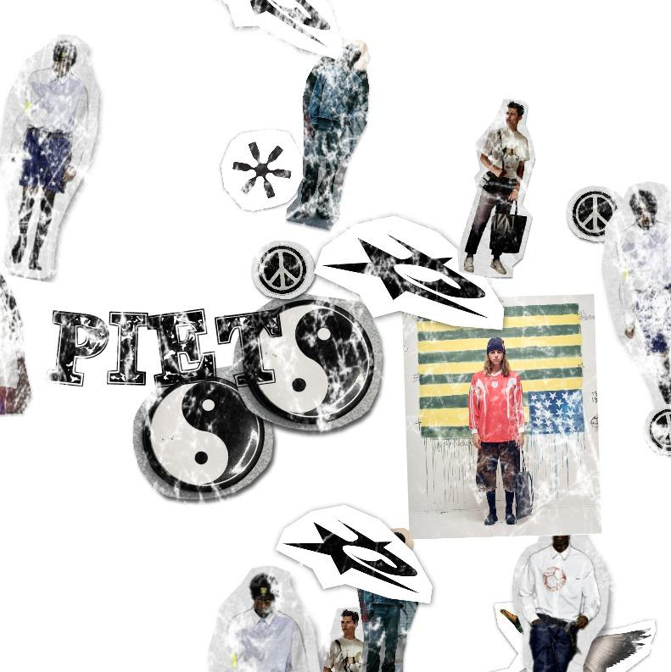

Source: By the author, 2025.

Figure 22: Second variation of the algorithmic collage, with reorganization of the same visual elements and controlled randomization of position, scale, and overlap.

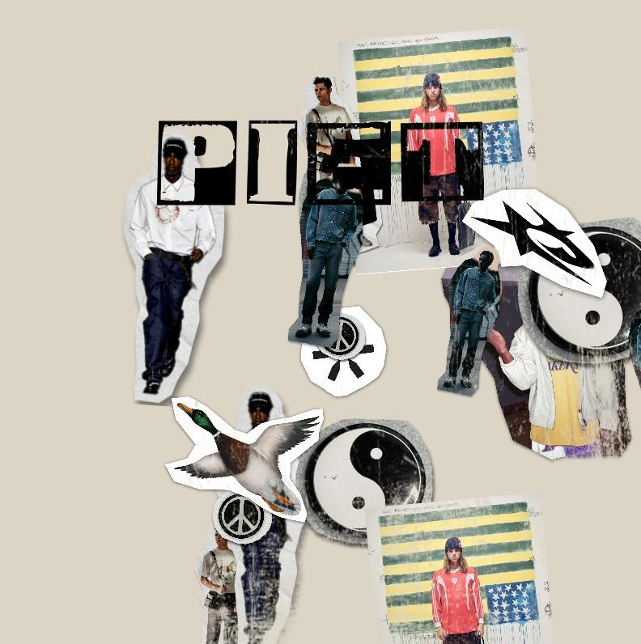

Source: By the author, 2025.

Figure 23: Third variation of the experiment, highlighting the system's generative behavior and the emergence of unprecedented compositions from the same set of assets

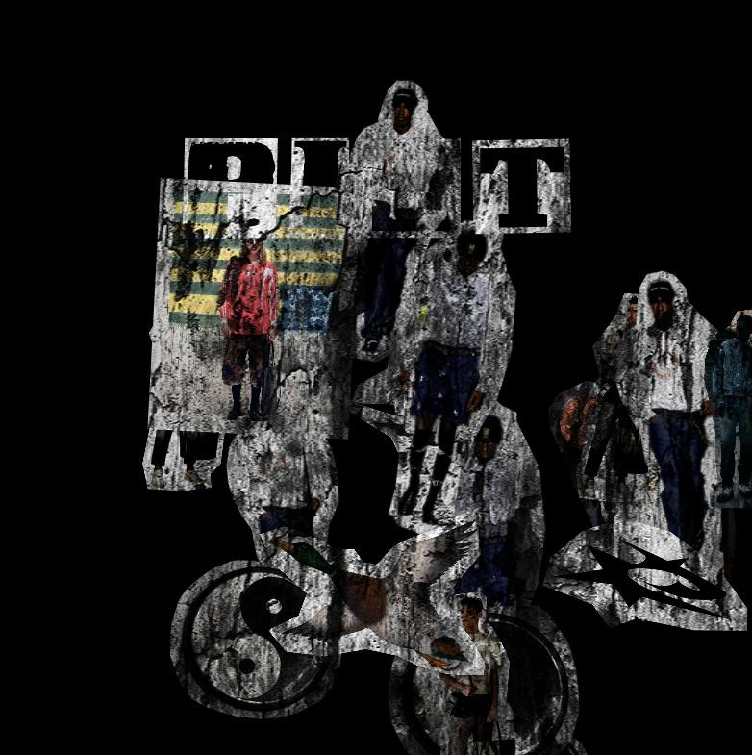

Source: By the author, 2025.

### Technical Structure of the System

The system was developed in p5.js, prioritizing simple rules of controlled randomization. Each new composition is generated through a set of parameters derived directly from the brand identity analysis. These include:

* Asset Library: A set of PNGs and JPEGs cut from campaigns, editorials, icons, and photographs. Each composition randomly selects a subset of these elements, treating them as "cultural particles."
* Base Palette: Colors used by the brand—Black, White, Blue, Bone—used to define the background. This chromatic limitation sustains consistency and recognizability.
* Probabilistic Positioning: The use of the randomGaussian()² function concentrates elements near the center, creating a visual focus and avoiding total dispersion. The composition results in "chaos with intention."
* Central Typography: The word "PIET" is applied as a layer, using a curated set of typographies that dialogue with the brand concept and the experiment's aesthetics.

Figure 24: PIET color palette. Generated in the Coolors tool based on research conducted by the author.

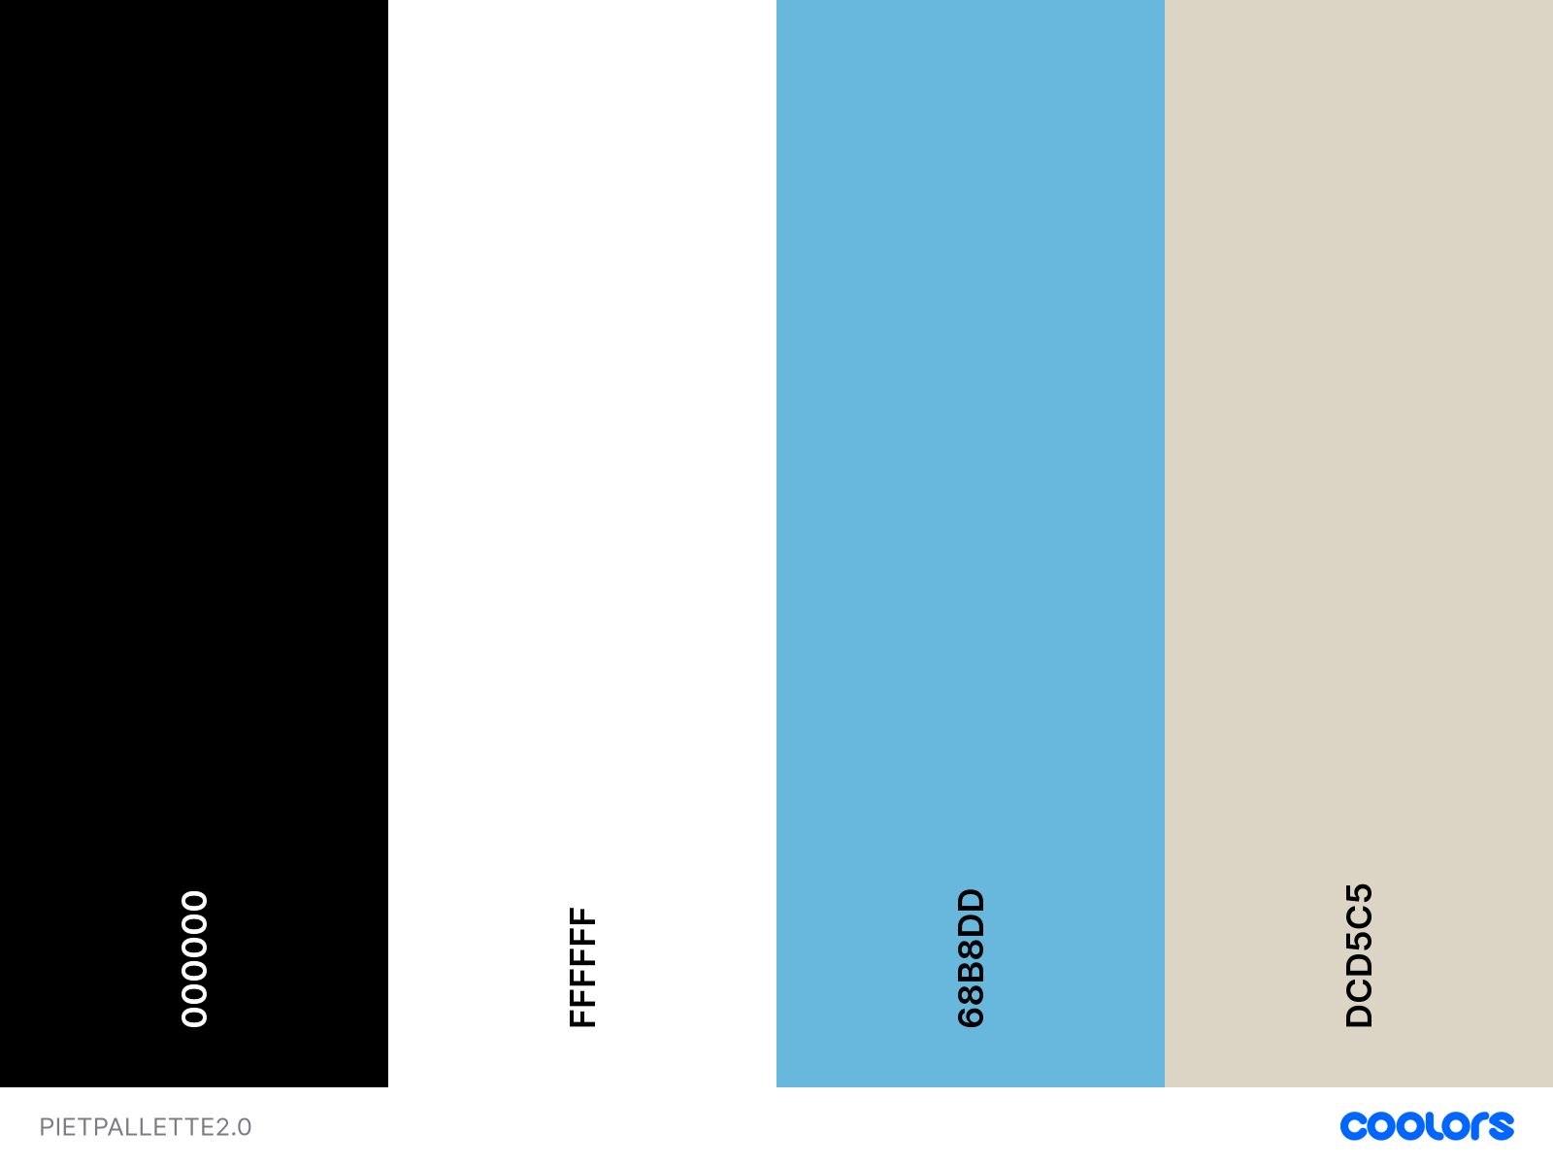

Source: By the author, 2025

These parameters sought to form a visual ecosystem that balances randomness and structure. The brand remains recognizable even when elements vary, evidencing that PIET possesses an "identity core" solid enough to support generative variation.

The randomGaussian() function returns a random value within a normal distribution, such that this value clusters around a mean within a standard deviation range. When applied to contexts like radial distance from the center, the generated value can position images in a well-distributed manner around that center, avoiding extreme positions like the corners of the image.

### Visual Results and Interpretation

With each interaction, the system produces a unique collage reflecting PIET’s symbolic universe. Although each composition is new, they all share structural characteristics that place them within the same aesthetic field: imagery density, intense overlapping, controlled visual noise, and brand centrality. The word "PIET," applied as the top layer, functions as a stamp: while it records the chaotic encounter of references, it rationalizes it and provides unity.

The experiment sought to demonstrate that visual identities can operate as evolutionary and responsive systems, preserving cohesion while amplifying diversity. In PIET’s case, the result reinforces the brand's philosophy: a visual organism that absorbs influences, tensions boundaries, and reinscribes itself with each new combination of fragments. However, it remained necessary to test these ideas with an audience.

### Perception Tests

To evaluate the visual artifacts generated by the PIET experiment and understand if the intended results were confirmed, an exploratory and qualitative perception testing methodology was structured and applied. The objective was to investigate how formal variations affect the perception of brand coherence, innovation, and authenticity for both familiar and unfamiliar audiences.

The approach, lasting approximately 20 minutes per participant, was applied to a total of five (5) participants. Of these, three (3) declared prior knowledge of the PIET brand, while two (2) did not, allowing for a comparative analysis of perception. During the sessions, six (6) images (Figures 21 to 23 previously presented and Figures 25 to 27 below) were used as visual stimuli to guide the interviews.

Figure 25: Fourth variation generated by the system, with the logo applied in white texture on a blue background.

### 

Source: By the author, 2025.

### Figure 26: Fifth variation of the experiment, testing the application of the generated composition on a white background.

### 

Source: By the author, 2025.

Figure 27: Sixth variation of the series, showing the logo in a black outline and a new arrangement of visual elements.

### 

Source: By the author, 2025.

The application followed the three planned stages, and data analysis was conducted through thematic content analysis, focusing on the proposed dimensions.

### Analysis Results

The analysis of the responses from the five participants (presented in full in Appendix 3) revealed patterns regarding the effectiveness of the generative system.

1. Visual Coherence and Concept Understanding: There was a consensus on the perception of the brand's personality, confirming the system's coherence and its central concept.

* Segment Identification: All participants, including those unfamiliar with the brand, correctly associated it with the "streetwear" universe. Terms like "modern streetwear" (Participant 3), "street, skate" (Participant 5), "urban" (Participant 2), and "relaxed, casual" (Participant 1) were recurrent.
* Collage Metaphor: The system's aesthetics were well understood. Participant 2 described it as a "brand moodboard" and compared it to "worn-out wheatpastes (*lambe-lambe*) on the walls of São Paulo." Participant 5 mentioned "stickers people would put on window panes," confirming that the "algorithmic collage" metaphor was successfully perceived.
* Conceptual Understanding (Polyculture): Notably, Participant 1 captured the exact conceptual intention of the experiment. Upon seeing the variations, they mentioned an "idea of polyculture" and the feeling of "drinking from different sources, different cultures." This perception confirms the system's proposal of using collage as an operational metaphor to represent the "unusual union" that defines PIET.

2. Authenticity and Innovation Perception: This dimension revealed the greatest divergence among participants, exposing a central tension regarding the use of generative systems in artistic and visual creation. The question "Does knowing the images were created by a generative system change anything?" divided the group:

* Neutral/Positive Perception: Three participants (1, 3, and 5) did not have a negative perception. Participant 1 saw the practice as positive, stating the brand "adheres to what is current in the market" and "does not cling to retrograde things." Participant 5 found it "very interesting" and felt the result seemed "more personal."
* Negative Perception: Two participants (2 and 4) reported a loss of value. Participant 2, who associates fashion with art, stated it would "take away some of the value of the pieces" and that it "loses some of the charm" when thinking it was not a human process. Participant 4 echoed this, saying "if they were created by a person, it would make more sense."

3. Identity Elasticity and System Limits: The test sought to identify the breaking point of the identity. Results indicate the system is highly elastic but has clear limits defined by legibility.

* Perceived Consistency: All five participants stated they perceived a "pattern" or "consistent identity" despite the variations. Consistency was anchored in the "more urban vibe" (Participant 2), the recurrent use of the "same images" (Participant 2), and the "collage technique" (Participant 1).
* The Breaking Point (The Limit): There was a unanimous consensus on which variations "strayed" or "would generate confusion." One variation was rejected by nearly all participants. Participant 2 stated it would "cause confusion" because "you can't see it clearly." Participant 5 said, "you can't see the idea." This suggests that variation fails when it compromises visual legibility, especially in the black-background versions.

### Synthesis of Test Conclusions

The application of perception tests allowed for three main conclusions:

1. Concept Communication: The generative system was effective in communicating PIET's essence. Participants correctly identified the niche and the "polyculture" metaphor.
2. Authenticity Tension: The revelation of the generative process exposes a risk in perceived value. It is possible participants associated "generative" with Generative AI tools. Future improvements should refine the test script to better contextualize the system's operation, dissociating it from common perceptions of AI.
3. Critical Legibility Limit: Brand elasticity is high but not infinite. Curation and rule-setting in generative systems must prioritize clarity to avoid confusion.

# Conclusion

This research began with the objective of challenging the traditional perception of a visual identity as a static symbol, proposing that it can evolve through algorithmic systems. It also sought to illustrate how Generative Design fosters adaptability and innovation, while elucidating its capacity to reinforce or challenge conventional aesthetics and communication. At the conclusion of the investigation, the results indicate that it was possible to explore the proposed objectives in depth.

The experiment with the PIET brand served as a direct response to the first objective. By translating PIET's identity into an "algorithmic collage" system, the study sought to practically challenge the static nature of the brand. The system was conceived as a "living organism" capable of reflecting the "unusual union between streetwear, sportswear, art, and urban subcultures." A strong indicator of the effectiveness of this challenge came from the perception tests, where a participant, without prior knowledge of the concept, identified the "idea of polyculture" and the feeling of "drinking from different sources, different cultures." This suggests that the generative system was successful in communicating the brand's value proposition dynamically.

The second objective sought to evaluate adaptability and innovation. The interviews with specialists corroborated this view in a complementary manner. Patrik Hübner positioned innovation as a crucial strategic differentiator in saturated international markets, where clients seek new forms of storytelling to stand out. Similarly, André Burnier described it, within the national context, as an aesthetic "Pandora’s box"—a response to the need for variation for an audience that quickly grows bored. In both cases, generative innovation is seen as a viable solution to the demands of the contemporary market.

Finally, the research elucidated the tension between reinforcing and challenging brand communication. The data suggest that the generative system successfully reinforced PIET's identity: all participants, including those unfamiliar with the brand, correctly identified its personality as "streetwear," "urban," and "relaxed." However, the investigation also pointed out clear limits to this challenge:

* The Authenticity Limit: The study indicated a "tension in authenticity." For two of the five test participants, knowledge of the generative process diminished the perceived value of the creation, as they preferred the narrative of a human creator.
* The Legibility Limit: Tests suggested a "breaking point" where one of the aesthetic variations compromised legibility, being universally rejected for generating confusion.
* The Market Limit: The research revealed that the main challenge for adopting the methodology is not technical, but cultural and educational. In both contexts, specialists reported the fundamental need to "educate" the client. As pointed out by André Burnier, in the Brazilian scenario, this challenge is more basic: justifying the value of the practice and the perceived "loss of control." In the international scenario, as described by Patrik Hübner, the challenge is more strategic: elevating the discussion from the "how" (technology) to the "why" (narrative).

This research sought to challenge the traditional perception of visual identity as a "static symbol" and investigate its potential evolution into dynamic visual identity systems, elucidating the complex tension between Generative Design's capacity to reinforce or challenge a brand's communication. The results indicate that Generative Design is a high-capacity tool for reinforcing the conceptual core. The experiment with PIET demonstrated this in practice by executing the brand’s philosophy and successfully communicating its "idea of polyculture," confirmed in perception tests. However, the research also mapped the limits of this challenge. The success of this approach proved not to be absolute, indicating that its future depends less on technical evolution and more on the ability to manage the identified tensions and the continuous effort to educate the market beyond the static symbol.

# 

# References

AVIS, M.; HENDERSON, I. L. A solution to the problem of brand definition. **European Journal of Marketing**, v. 56, n. 9, p. 2577-2598, 2022.

BAILEY, Jason. Why Love Generative Art. **Artnome**, 8 ago. 2018. Available at: https://www.artnome.com/news/2018/8/8/why-love-generative-art. Accessed on 28 mar. 2025.

BARDIN, Laurence. **Análise de Conteúdo**. São Paulo: Almedina, 2011.

DANG, Ly. **Visual Branding: A Guide to Designing Visual Identity**. Advisor: Thomas Sabel. 2018. 65 f. TCC (Graduação) - Curso International Business, Vaasa University of Applied Sciences, Vaasa, 2018.

DIGITAL ART MUSEUM - DAM. (Des)Ordres. **Vera Molnár**. Paris, 1974. Available at: https://dam.org/museum/artists_ui/artists/molnar-vera/des-ordres/. Acesso em 16 de novembro de 2025

DONOGHUE S. Projective techniques in consumer research. **Journal of Consumer Sciences**. v.28, n. 1, 2000. Available at: https://www.ajol.info/index.php/jfecs/article/view/52784. Acesso em 14 nov. 2025

DZYABURA, D. PERES, R. Visual elicitation of brand perception. **SSRN**. 2020. Available at: https://papers.ssrn.com/sol3/papers.cfm?abstract_id=3496538. Acesso em 14 nov. 2025

FEKETE, Balàzs. Digital dynamics visual identities – prospects at the frontiers of marketing and design. **Budapest Management Review**, v. 53, n. 1, p. 4-21, 2022.

GALANTER, Philip. What is Generative Art? Complexity Theory as a Context for Art Theory. **Generative Art Conference**, 6., 2003, Milão. Proceedings of the Generative Art Conference. Milão, 2003.

GUIDA, F. E. Generative Visual Identities. New Scenarios in Corporate Identity. **Generative Art Conference**, 17., 2014. Proceedings of the XVII Generative Art Conference - GA2014. 2014.

HÜBNER, P. Schwanensee. **Patrik Hübner**. Paderborn, 2018. Available at: https://www.patrik-huebner.com/generative-design/schwanensee-a-dynamic-identity-driven-by-dance/. Acesso em 16 novembro 2025.

LELIS, Catarina. Like a chameleon: The polychromatic virtue of dynamic brands. **Journal of Product & Brand Management**, v. 28, n. 4, p. 496-509, 2019.

LELIS, Catarina; LEITÃO, Sandra; MEALHA, Óscar; DUNNING, Ben. Typography: The constant vector of dynamic logos. **Visual Communication**, London, v. 19, n. 4, p. 505-528, 2020.

MAEDA, John. **Maeda Studio**. 2025. Available at: https://maedastudio.com/ Accessed on 14 nov. 2025.

MALHOTRA N. **Marketing research: an applied orientation**. 7ª ed. Londres: Pearson, 2018.

MCEVOY, Turlough. How Heritage is the Ultimate Brand Flex: The Nike Case Study. **Medium**, 11 ago. 2024. Available at: https://medium.com/@turloughmcevoy/how-heritage-is-the-ultimate-brand-flex-the-nike-case-study-2361d9aebc4a. Accessed on nov 21th 2025.

MSN. Why Does the Apple logo have a bite mark? **MSN**, 2025. Available at: https://www.msn.com/en-us/news/technology/why-does-the-apple-logo-have-a-bite-mark/ar-AA1DBNGV. Accessed on nov 21th 2025.

MUSEO REINA SOFIA. Cuatro Caras. **Museo Reina Sofia**. Available at: https://www.museoreinasofia.es/en/collection/artwork/cuatro-caras-four-faces. Accessed on mar 28th 2025.

NEUE DESIGN STUDIO. Visit Nordkyn. **Neue Design Studio**. Oslo, 2012. Available at: https://neue.no/work/visit-nordkyn/. Accessed on nov 17th 2025.

NOCLIMA. Branding versus Blanding. **Medium**, 5 jan. 2024. Available at: https://noclima.medium.com/branding-versus-blanding-976dc7f508f7. Accessed on nov 21th 2025.

PIET. Piet. 2025. Available at: https://piet.com.br/. Accessed on nov 21th 2025.

PINTEREST. Variations of the MTV logo, one of the precursors of dynamic visual identity. **Pinterest**. [s.d.]. Available at: https://br.pinterest.com/pin/587930926339176549/. Accessed on nov 21th 2025.

SAGMEISTER, Stefan. Casa da Musica Identity, Logo Generator. **The Museum of Modern Art (MoMA) Collection**. 2007. Available at: https://www.moma.org/collection/works/145254. Accessed on nov 21th 2025.

SCHROEDER, J. E. The artist and the brand. **European Journal of Marketing**, v. 39, n. 11/12, p. 1291-1305, 2005.

SCHROEDER, J. E. Corporate branding in perspective: A typology. **European Journal of Marketing**, v. 51, n. 9/10, p. 1522-1531, 2017.

STÄDEL MUSEUM. Figure. **Städel Museum**. Available at: https://sammlung.staedelmuseum.de/en/work/figure. Accessed on mar 28th 2025.

THE MUSEUM OF MODERN ART. Andy Warhol, Campbell's Soup Cans, 1962. **The Museum of Modern Art**. 2025. Available at: https://www.moma.org/collection/works/79809. Accessed on mar 12th 2025.

VAN NES, Irene. **Dynamic Identities: How to Create a Living Brand**. Amsterdam: BIS Publishers, 2012.

VIEIRA, B. L.; BRUSCATO, L. M. Parâmetros para a criação de sistemas generativos de identidade visual. **Estudos em Design**, Rio de Janeiro, v. 31, n. 1, p. 138-161, 2023.

WHEELER, Alina. **Designing Brand Identity: An Essential Guide for the Whole Branding Team**. 5. ed. Hoboken: Wiley, 2017.

# Appendices

### Generative Design Works Catalogue

| **Title** | **Author** | **Year** | **Technique of Interest** | **Description** | **Is it a case?** | **Tags** | **Reference** |
| --- | --- | --- | --- | --- | --- | --- | --- |
| Philharmonie Luxembourg | Patrik Hübner | – | Morphology, Chromatics | A dynamic identity that interacts with live music, translating sound into visual forms. | ✓ | generative design, dynamic visual identity | [Link](https://www.patrik-huebner.com/generative-design/philharmonie-luxembourg-a-dynamic-identity-that-interacts-with-the-sound-of-live-music/) |
| BRUTE | Patrik Hübner | – | Morphology | A data-driven wine brand utilizing generative design to reflect its bold character. | ✓ | generative design, dynamic visual identity | [Link](https://www.patrik-huebner.com/generative-design/brute-data-driven-wine-brand/) |
| Lexus NX 100 Thieves | Patrik Hübner | – | Morphology, Chromatics | A generative art car design blending Lexus aesthetics with 100 Thieves' gaming culture. | ✓ | generative design, artwork | [Link](https://www.patrik-huebner.com/generative-design/lexus-nx-100-thieves-generative-art-car-design/) |
| Munken Creator | Patrik Hübner | – | Typographic Composition | A generative typography tool allowing users to create unique typographic compositions. | ✓ | generative design | [Link](https://www.patrik-huebner.com/generative-design/munken-creator-generative-typography-design/) |
| The Pulse | Patrik Hübner | – | Chromatics | A real-time data-reactive visual that changes based on live inputs. | ✓ | generative design, dynamic visual identity | [Link](https://www.patrik-huebner.com/generative-design/the-pulse-a-real-time-data-reactive-living-key-visual/) |
| Polkadot | Patrik Hübner | – | Morphology | A community-driven brand identity designed to evolve with its users. | ✓ | generative design, dynamic visual identity | [Link](https://www.patrik-huebner.com/generative-design/polkadot-a-community-driven-brand-that-is-built-to-evolve/) |
| Stadttheater Gießen | Patrik Hübner | – | Morphology | A dynamic performance language brand identity for a theater. | ✓ | generative design, dynamic visual identity | [Link](https://www.patrik-huebner.com/generative-design/stadttheater-giessen-dynamic-performance-language-brand-identity/) |
| PETRONAS | Patrik Hübner | – | Morphology, Chromatics | An ever-evolving design system aiming to inspire change. | ✓ | generative design, dynamic visual identity | [Link](https://www.patrik-huebner.com/generative-design/petronas-an-ever-evolving-flexible-design-system-to-inspire-change/) |
| evian+ Toolkit | Patrik Hübner | – | Chromatics | A branding toolkit transforming foggy feelings into fizzy clarity. | ✓ | generative design, dynamic visual identity | [Link](https://www.patrik-huebner.com/generative-design/evian-transforming-foggy-feelings-into-fizzy-clarity/) |
| BLAU | Patrik Hübner | – | Morphology | A participatory identity that evolves with its community. | ✓ | generative design, dynamic visual identity | [Link](https://www.patrik-huebner.com/generative-design/blau-a-dynamic-participatory-identity-that-evolves-with-its-community/) |
| Elsevier Clinical Key | Patrik Hübner | – | Typographic Composition, Chromatics | A data-driven expressive branding toolkit for medical professionals. | ✓ | generative design, dynamic visual identity | [Link](https://www.patrik-huebner.com/generative-design/clinical-key-a-data-driven-expressive-branding-toolkit/) |
| Mivolis Artifeel | Patrik Hübner | – | Morphology, Chromatics | A dynamic and scalable brand design reflecting personal feelings. | ✓ | generative design, dynamic visual identity | [Link](https://www.patrik-huebner.com/generative-design/mivolis-artifeel-dynamic-scalable-brand-design/) |
| Surface | Patrik Hübner | – | Morphology, Chromatics | An interactive generative campaign for a product launch. | ✓ | generative design, dynamic visual identity | [Link](https://www.patrik-huebner.com/generative-design/surface-interactive-generative-clp/) |
| The Beethoven Phenomenon | Patrik Hübner | – | Morphology, Chromatics | Exhibition communication formed by Beethoven's music. | ✓ | generative design, artwork | [Link](https://www.patrik-huebner.com/generative-design/the-beethoven-phenomenon-exhibition-communication-formed-by-beethovens-music/) |
| Schwanensee | Patrik Hübner | – | Morphology | A dynamic identity driven by dance movements. | ✓ | generative design, dynamic visual identity | [Link](https://www.patrik-huebner.com/generative-design/schwanensee-a-dynamic-identity-driven-by-dance/) |
| Art Machines | Patrik Hübner | – | Morphology | A flexible dynamic identity propelled by people. | ✓ | generative design, dynamic visual identity | [Link](https://www.patrik-huebner.com/generative-design/art-machines-a-flexible-dynamic-identity-propelled-by-people/) |
| La Cosette | Patrik Hübner | – | Chromatics | 100,000 unique wine bottles with generative labels. | ✓ | generative design, artwork | [Link](https://www.patrik-huebner.com/generative-design/la-cosette-100-000-unique-wine-bottles/) |
| SHUTDOWN Gallery | Patrik Hübner | – | Morphology | A web-based AR/VR 3D experience for a digital gallery. | ✓ | generative design, artwork | [Link](https://www.patrik-huebner.com/generative-design/shutdown-gallery-a-web-based-ar-vr-3d-experience/) |
| Chimes | Patrik Hübner | – | Morphology, Chromatics | An interactive exploration of music and space. | ✓ | generative design, artwork | [Link](https://www.patrik-huebner.com/generative-design/chimes-an-interactive-exploration-of-music-and-space/) |
| DIESEL Go with the flaw | Patrik Hübner | – | Morphology, Chromatics | A campaign embracing imperfections through generative visuals. | ✓ | generative design, dynamic visual identity | [Link](https://www.patrik-huebner.com/generative-design/diesel-go-with-the-flaw/) |
| Generative Logo Synthesizer | Patrik Hübner | – | Typographic Composition, Morphology | A tool for creating generative logos based on user input. | ✓ | generative design, dynamic visual identity | [Link](https://www.patrik-huebner.com/generative-design/generative-logo-synthesizer/) |
| How Scanners Work | Patrik Hübner | – | Morphology | A visual exploration of scanner mechanics using generative design. | ✓ | generative design, artwork | [Link](https://www.patrik-huebner.com/generative-design/how-scanners-work/) |
| McKinsey Dynamic Identity Explorations | Patrik Hübner | – | Morphology, Chromatics | Explorations of dynamic identities for corporate branding. | ✓ | generative design, dynamic visual identity | [Link](https://www.patrik-huebner.com/creative-coding/mckinsey-dynamic-identity-explorations/) |
| Absurdo. | Sebastián Mejía, David Martínez, Estefanía Mejía | 2018 | Morphology, Chromatics | A generative brand identity showcasing diversity through algorithmic visuals. | ✗ | generative design, dynamic visual identity | [Link](https://www.behance.net/gallery/64250469/Absurdo-Generative-visual-identity) |
| Absolut Unique | Absolut. | 2012 | Chromatics, Morphology | A limited edition of 4 million uniquely designed and numbered vodka bottles. | ✓ | generative design, artwork | [Link](https://www.absolut.com/pt-br/absolutcollaborations/absolut-unique/) |
| Apraava Energy | Apraava Energy | 2021 | Morphology, Chromatics | A generative brand identity powered by data from energy plants and local weather. | ✓ | generative design, dynamic visual identity | [Link](https://www.apraava.com/getmedia/f31b7956-30a1-4735-ac9e-c30790f519b1/The-Hard-Copy_Apraava-Energy.pdf?ext=.pdf) |
| Pedra Passáro | Leston Studio | 2023 | Morphology, Chromatics | A generative series of 3D prints blending mineral and animal forms. | ✓ | generative design, artwork | [Link](https://leston.studio/) |
| Rio Carnaval | André Burnier | 2022 | Morphology, Chromatics | A dynamic logo generated live through custom software reflecting the carnival spirit. | ✓ | generative design, dynamic visual identity | [Link](https://www.andreburnier.com/project/riocarnaval) |
| Enjoei | André Burnier | 2019 | Chromatics | A tool allowing users to create patterns with customizable characters and colors. | ✓ | generative design, dynamic visual identity | [Link](https://www.andreburnier.com/project/enjoei) |
| TBWA | André Burnier | 2020 | Morphology | A tool for designing custom lettering in motion for various applications. | ✓ | generative design, dynamic visual identity | [Link](https://www.andreburnier.com/project/tbwa) |
| Periplo | André Burnier | 2021 | Morphology | A visual identity reflecting the journey and evolution of a performing arts company. | ✓ | generative design, dynamic visual identity | [Link](https://www.andreburnier.com/project/periplo) |
| Lume | André Burnier | 2020 | Chromatics, Morphology | A generative design expressing the movement of actors through variable typography. | ✓ | generative design, dynamic visual identity | [Link](https://www.andreburnier.com/project/lume) |
| Ciddic | André Burnier | 2019 | Typographic Composition, Chromatics | A flexible visual identity allowing autonomy for each organ within the center. | ✓ | generative design, dynamic visual identity | [Link](https://www.andreburnier.com/project/ciddic) |
| Nusom | André Burnier | 2021 | Morphology, Chromatics | A visual identity reflecting the experimental nature of a sound research center. | ✓ | generative design, dynamic visual identity | [Link](https://www.andreburnier.com/project/nusom) |
| Marcacos | André Burnier | 2020 | Chromatics | A branding project utilizing generative design to create unique visual elements. | ✓ | generative design, dynamic visual identity | [Link](https://www.andreburnier.com/project/marcacos) |
| 10,000 Digital Paintings | Field.io | 2014 | Chromatics | A series of 10,000 unique generative artworks for GF Smith's paper brochures. | ✓ | generative design, artwork | [Link](https://field.io/work/10-000-digital-paintings) |
| MTV Logo Variants | MTV (Viacom) | 1981 | Morphology, Chromatics | A versatile logo design allowing endless variations to reflect different themes. | ✓ | dynamic visual identity |  |
| Florada | John Maeda | 1990s | Morphology, Chromatics | A generative artwork exploring the intersection of nature and computation. | ✗ | generative design, artwork |  |

### Interview with Specialists: script (in Portuguese)

Warm up question:

* "Pra gente começar, você poderia me contar um pouco sobre sua trajetória e como o design generativo entrou no seu radar e, eventualmente, na sua prática profissional?"

Creative Process, Tools and Workflow:

* "Pensando em um projeto de identidade visual, qual você diria que é a principal mudança no processo criativo ao usar uma abordagem generativa em comparação com um método mais tradicional?"
* "Com base nesse novo processo, como você descreve sua atuação? Você se sente mais como um curador que seleciona os melhores resultados, um diretor que define as regras do sistema, ou talvez outra coisa?"
* "Falando em ferramentas, quais são as que você mais utiliza nos seus projetos generativos? Existe uma diferença entre as ferramentas que você usa para um projeto de identidade visual versus, por exemplo, um pôster ou uma instalação de arte?"
* "E como você costuma desenhar seu fluxo de trabalho? Poderia descrever, de forma geral, as etapas que vão desde o briefing até a entrega de um sistema de identidade generativo?"

Relationship with Market and Customers:

* "Agora, pensando no mercado. Qual o nível de maturidade que você percebe nos clientes para entender e investir em uma identidade visual generativa?"
* "Normalmente, eles já chegam buscando essa inovação ou existe um trabalho seu de apresentar e 'educar' o cliente sobre o potencial dessa abordagem?"
* "Na sua visão, agora pode ser um momento interessante para explorar o design generativo em marcas? O que mudou, na tecnologia, na cultura ou nos próprios clientes, que pode ter criado essa 'janela de oportunidade'?"
* "Depois que um projeto generativo vai para a rua, como tem sido a adaptação? E aqui penso tanto no cliente, que precisa aprender a 'usar' uma marca fluida, quanto na percepção do público final. O que você tem observado?"

Aesthetics, Innovation and Brand Perception

* "Em termos de estética, o que o design generativo realmente traz de novo? Ele está criando uma linguagem visual inédita ou acelerando e variando estilos que já conhecíamos?"
* "Um dos grandes desafios parece ser manter a consistência. Como você garante que, mesmo com inúmeras variações visuais, a essência e os valores da marca permaneçam coesos e reconhecíveis?"

Ending and View of Future

* "Olhando para frente, qual você acha que é o maior desafio ou a próxima fronteira a ser superada para que o uso de design generativo em identidades visuais se torne mais comum?"
* "Para fechar, tem algo que eu não perguntei e que você considera fundamental para entender o universo do design generativo aplicado a marcas?"

### Perception Tests - transcripts (in Portuguese)

Você conhece a marca Piet?

* **Participante 1:** Sim.
* **Participante 2**: Sim.
* **Participante 3:** Não.
* **Participante 4:** Sim.
* **Participante 5:** Não conheço.

Que sensações ou ideias essas imagens despertam em você?

* **Participante 1:** A primeira me dá mais um sentido de adolescência. Parece um collab que a Malhação faria. A última me dá uma ideia de policultura, não sei por quê, mas eu gostei, achei legal. A penúltima também. Acho que muito por conta das bandeiras me dá essa sensação de beber de fontes diferentes, culturas diferentes. A segunda é minha favorita, a logo tá muito bem colocada. Vejo isso em uma estampa de camiseta. Gosto da cor do fundo. Acho que é a que menos atrapalha esteticamente o recebimento da mensagem Piet.
* **Participante 2:** Eu tô vendo uns recortes, parece que a ideia é passar uma ideia mais urbana, mais descolada, e é como se fosse talvez um moodboard da marca, talvez estilizado.
* **Participante 3:** Me parece um modelo streetwear moderno.
* **Participante 4:** Dá ideia de descolado, aventura, jovem, essas coisas, que cursa Artes Visuais ou FFLCH.
* **Participante 5:** Me remete a uma marca de roupa tipo streetwear e um pouco aqueles colantes que as pessoas colavam nos vidros das janelas.

(Caso a pergunta 1 tenha resposta negativa) Observando as imagens, qual segmento comercial você acha que essa marca Piet trabalha?

* **Participante 1:** Não aplicável
* **Participante 2:** Não aplicável
* **Participante 3:** Não sei se entendi bem essa pergunta, mas com base no que entendi, seria o segmento de moda.
* **Participante 4:** Não aplicável
* **Participante 5:** Trabalha com roupas.

Como você descreveria a personalidade ou estilo que as imagens transmitem?

* **Participante 1:** Despojado, casual e talvez a primeira imagem mais juvenil. Muito pelo tom de azul, muito pela forma das colagens. Também diria que elas são retrô, vejo isso sendo uma propaganda dos anos 2000.
* **Participante 2:** Urbano, street style.
* **Participante 3:** Parece ser uma marca voltada para o público jovem atual, como disse, o streetwear moderno.
* **Participante 4:** A personalidade de um jovem universitário e maconheiro.
* **Participante 5:** Parece algo bastante street, skate, algo assim. Mas, ao mesmo tempo, com roupas mais sociais, talvez? Tipo bem metrópole, cidade grande.

Qual dessas variações parece mais representativa da marca? Por quê?

* **Participante 1:** A segunda, por que é a que menos atrapalha a ideia da marca. Então, a primeira coisa que eu olho é: tá, isso é uma marca de roupa. Se eu não conhecesse a PIET, a primeira coisa que eu pensaria é: isso deve ser uma marca de roupa e ela deve se chamar PIET. Nada me surpreende aí, entende? Não deixa de me surpreender em um sentido negativo, mas o ponto focal tá certo na minha impressão, então eu consigo obter a mensagem de que isso é PIET e provavelmente é uma marca de roupa. E passa uma mensagem de que, como eu conheço a marca, sei que é algo mais casual, algo mais street, focado nesse tipo de moda.
* **Participante 2:** Eu diria a que tem o fundo branco, por que a visão que eu tenho da Piet são roupas mais clean, mais básicas. Esse azul nunca vi na Piet, então eu descartei. Esse efeito em cima das imagens, como se fosse uma marca e amassado, isso me remete à marca também. Algumas estampas que eu já vi.
* **Participante 3:** Não aplicável
* **Participante 4:** Tal variação. Achei mais braba, harmônica.
* **Participante 5:** Não aplicável

Saber que as imagens foram criadas por um sistema generativo muda algo na sua percepção da marca?

* **Participante 1:** Nada, só acho que a marca adere ao que tá vigente no mercado. Eu gosto, acho que não se apega a coisas retrógradas.
* **Participante 2:** Sim. Por que o que eu espero de uma marca de roupa, moda, né? Moda é arte também. Eu espero criatividade. Não que esse processo não envolva criatividade, mas talvez eu ficaria pensando: será que para gerar uma estampa eles usam sistemas assim? E, particularmente, isso tiraria um pouco do valor das peças, de pensar que não foi uma pessoa que sentou ali, projetou, escolheu e criou. Perde um pouco da graça.
* **Participante 3:** Não.
* **Participante 4:** Sim, acho que se fosse criadas por uma pessoa, faria mais sentido. Pensando que a marca está tentando se conectar mais com o público.
* **Participante 5:** Não, eu achei bem interessante, na verdade. De primeira, não pensei que poderia ter sido criada por computador e eu achei muito específica, me remeteu a lembranças de infância, igual eu falei que parecia colante de janela em quarto antigo. Pareceu algo mais pessoal assim. Não diria que foi uma pessoa que fez.

Entre as variações, quais parecem mais originais ou autênticas?

* **Participante 1:** A segunda parece mais original e autêntica, vejo a PIET usando ela. As outras talvez não.
* **Participante 2:** Todas têm imagens bem repetidas. A que eu escolhi que era mais parecida com a marca, a com fundo branco.
* **Participante 3:** A do fundo bege, acho que porque é a única que o nome fica visível e centralizado.
* **Participante 4:** Tais duas.
* **Participante 5:** A primeira.

Mesmo com tantas variações, você ainda percebe algum padrão ou uma identidade consistente?

* **Participante 1:** Percebo, todas utilizam colagem, todas tentam dar ênfase na marca e todas me falam sobre a PIET como uma marca meio underground que conversa muito com gente do esporte, atleta, etc.
* **Participante 2:** Sim, dá pra perceber. As mesmas imagens estão em todas as colagens e todas têm uma pegada mais urbana, todas as imagens transmitem isso. Parece aquelas colagens que você vê tipo em lambe-lambe, que você vê nos muros de São Paulo. Bem ferradas de tomar chuva e sol.
* **Participante 3:** Sim, não vejo muitas mudanças entre as imagens, vejo modelos largados das informações.
* **Participante 4:** Uma identidade consistente. As que eu não escolhi parecem mais bagunçadas.
* **Participante 5:** Sim, todas parecem despojadas e com recortes sem padrão.

Até que ponto essas variações ainda “soam como Piet”?

* **Participante 1:** A primeira soa bastante, vejo uma estampa de camisa com essa logo, algo como se fosse um quadro branco e a colagem no meio, ou só essa colagem em uma camiseta oversized ou cropped. A segunda não vejo sendo.
* **Participante 2:** Sim, as duas. Então, eu não conheço muito, mas acho que todas estariam dentro do que eu interpreto como PIET.
* **Participante 3:** Acho que a imagem branca ainda se relaciona bem, a outra nem tanto. Essa imagem preta não dá para ver muita coisa.
* **Participante 4:** De primeira, falaria que as colagens.
* **Participante 5:** A com fundo branco ainda traz um ar despojado com recortes sem padrão, mas ainda tá muito clean comparada com as outras. Ainda consigo entender a ideia, mas tá um pouco diferente.

Há alguma imagem que pareça fugir do universo da marca?

* **Participante 1:** Não acho que fuja, só tem algumas que não me agradam tanto visualmente.
* **Participante 2:** Eu diria que não. Essa preta, ela tá mais diferente das outras imagens, mas da impressão que eu tenho, ela ainda estaria dentro.
* **Participante 3:** Não identifiquei nenhuma.
* **Participante 4:** A preta parece fugir um pouco, digo isso no feeling visual.
* **Participante 5:** A segunda, com o fundo preto, tem essa coisa mais desgastada das imagens, mas não dá para enxergar a ideia.

Se essas imagens fossem usadas em campanhas, quais reforçariam a identidade e quais poderiam gerar confusão?

* **Participante 1:** A primeira geraria identidade e a segunda pode gerar confusão, talvez pela forma da colagem, acho que tem muita informação.
* **Participante 2:** A preta geraria confusão se você usar em uma publicidade, por que não dá para enxergar direito o que tem nas imagens, aí você tá querendo expressar o quê? A que reforçaria, eu falaria que todas, exceto a preta e talvez a última branca, porque tem muita colagem sobreposta.
* **Participante 3:** As que reforçariam: o cara com a camisa do Lakers, a da bandeira e o cara de branco com boné. Acho que os adesivos do pato e yin e yang confundiriam.
* **Participante 4:** A preta e a branca por último gerariam confusão.
* **Participante 5:** A última com o fundo preto. Além disso, dentro das colagens, o pato também confunde um pouco e me parece estranho.